URS Probabilistic Tsunami Hazard System

A user manual

Version 1.00: 2012/01/12

|  |  |  |
| --- | --- | --- |
| Version | Date | Changes |
| 1.01 | open | Warning about the boundaries for Char distribution |
| 1.00 | 2012/01/12 | added instructions for edgrn and static-ed |
|  |  | minor corrections |
| .99 | 2012/01/11 | added to discussion on G-R and Max magnitude |
|  |  | added some notes on using cnltsunami_pas |
| .98 | 2011/12/22 | added Appendix B with info on GMT data formats and plot scripts |
|  |  | added input example for cnltsunami |
|  |  | additional text throughout |
| .97 | 2011/11/27 | added page numbers |
|  |  | added to performance based engineering (page 5) |
|  |  | added figure number and caption to first figure (flow chart), and renumbered other figures |
|  |  | added references |
|  |  | added output example figures (Figs 5,6,7) |

Table of Contents

Table of Contents 3

1 Introduction 5

2 Probabilistic Tsunami Hazard Analysis 5

2.1 Background 5

2.2 Overview of the URS approach 7

3 Detailed implementation 8

3.1 Tsunami modeling 8

3.1.1 Source excitation model 9

3.1.2 Tsunami computation 9

3.2 Probabilistic Analysis 14

4 Probabilistic offshore waveheight hazard 15

4.1 Overview 15

4.2 Green’s Function Summation 15

5 Source models 16

5.1 Geometry 16

5.2 Maximum Magnitude 17

5.3 Earthquake recurrence 17

5.4 Magnitude distributions 17

5.4.1 Gutenberg-Richter model 18

5.4.2 Maximum Magnitude model 19

5.4.3 Characteristic Magnitude model 22

6 Variability 22

6.1 Aleatory variability 22

6.1.1 Modeling Uncertainty 23

6.1.2 Dip Uncertainty 23

6.1.3 Slip Variability 23

6.1.4 Total Sigma and Epsilon Truncation 24

6.2 Epistemic uncertainties 24

6.2.1 Logic Trees 25

7 Programs 27

7.1 Source excitation 27

*7.1.1* *grid3* 27

*7.1.2* *edgrn* 27

*7.1.3* *static-ed* 27

7.2 Tsunami code 28

*7.2.1* *cnltsunami* 28

7.3 Probabilistic analysis 29

*7.3.1* *Hazts* 29

*7.3.2* *Tsunprob_dmx2* 29

*7.3.3* *Tsunprob_haz* 29

7.4 Post-processing 30

8 References 30

Appendix A: Annotated sample input and output files 32

Appendix B Generic Mapping Tools (GMT) 52

# Introduction

This manual describes the background and use of the URS Corporation’s set of codes to perform a Probabilistic Tsunami Hazard Analysis (PTHA). This set of codes is based on freely available existing third party software as well as software originally developed by URS. These codes were developed under grants and contracts from the United States Geological Survey through the National Earthquake Hazard Reduction Program (NEHRP) and the California Department of Transportation (Caltrans) through the Pacific Earthquake Engineering Research Center (PEER) (Thio et al., 2010).

# Probabilistic Tsunami Hazard Analysis

## Background

Probabilistic seismic hazard analysis (PSHA) has been a primary tool in the development of design criteria for buildings and infrastructure in engineering for the last few decades. Its use is intricately linked to the use of Performance Based Engineering (PBE) principles, where building design is based on several levels of performance (safe-use, collapse prevention, etc.), which are linked to a particular probability of exceedance of a ground motion level. Risk based analyses also inherently depend on a probabilistic expression of the hazard, and it is thus desirable to follow a similar framework for tsunami hazard analysis (McGuire, 2004).

For PTHA, the most obvious metric is the exceedance of a water level, or wave amplitude, since this can be readily translated into inundation, the most visible and dramatic consequence of tsunami waves. There however other metrics that may be more suited for certain purposes, such as flow velocities in ports and harbors or momentum for impact on structures. The current set of codes is setup to compute probabilities of wave height exceedance but can be adapted to model other metrics as well.

The probabilities are computed in terms of annual rate of exceedance, which, if we assume a Poissonian distribution, can be translated into probability of exceedance in a certain amount of time through:

$$P=1-e^{-γt}$$

where *P* is the probability of exceedance in a time period *t* (also called exposure time), and $γ$ the annual rate of exceedance. In engineering applications, we are usually interested in certain probability levels that are expressed in terms of *P*, such as a 2% (.02) probability of exceedance in 50 years, where 50 years is the exposure time *t*. Inverting the above equation as:

$$γ=\frac{-ln(1-P)}{t}$$

we can then calculate the corresponding annual rate of exceedance as .00040405 yr-1, or a recurrence time, often referred to as Average Return Period (ARP), of 2475 yr. Other periods of interest are 10% and 5% in 50 years, which correspond to 475 and 975 years ARP respectively.

In performance based engineering, these probability levels are tied to a specific performance level, for instance a building may be designed to remain operable for 475 yr ARP level ground motions, be temporarily inoperable but repairable within a reasonable amount of time for the 975 year ground motion levels and not collapse (but be permanently in-operable) for 2475 yr events (“life-safety”).

Probabilistic tsunami hazard analysis, like its seismic counterpart, follows a dualistic approach to probability. Whereas some aspects are defined in the familiar terms of frequency of occurrence (such as intermediate earthquake recurrence, magnitude distribution), others are more based on judgment, which is a subjective approach (Vick, 2002).

For instance, we may characterize the recurrence of intermediate earthquakes in terms of a Gutenberg-Richter distribution, constrained by a catalog of historical earthquakes. The assumption is that the occurrence of earthquakes is a stationary process, and that the catalog represents a homogenous sample of the long-term seismic behavior of a source. For large earthquakes however, the return times are so long relative to our historic record, even when paleo-seismic data is included, that the recurrence properties of these events cannot be described with a stationary model based on a regression of observed earthquake occurrence. We therefore need to introduce the concept of judgment, where we use our current understanding of earthquake processes, including analyses of similar structures elsewhere and other information, such as local geological conditions, strain rates etc., to make assumptions on the recurrence of large earthquakes. This is a subjective approach to probability, centered on the observer rather than the observations, and will inevitably be different from one practitioner to the other. A rigorous PTHA model therefore includes the use of logic trees to express alternative understandings of the same process, e.g. large earthquake recurrence, weighted by the subjective likelihood of that alternative model (“degree of belief”), where the weights of the alternatives sum to unity. We shall explain in a later section how this distinction is manifested in the handling of uncertainties throughout the analysis.

## Overview of the URS approach

In order to ensure consistency with seismic practice, the URS approach closely follows, where possible, the PSHA practice. For instance, early versions of this code borrowed heavily from the Haz36 PSHA code by Norm Abrahamson, and the overall framework remains quite similar to facilitate model exchange between the PSHA and PTHA codes. There are however some important differences between PSHA and PTHA. The most important difference between the two is the impracticality of using something similar to Ground Motion Prediction Equation (GMPE’s, aka Attenuation relations) in tsunami hazard due to the very strong dependence of tsunami waveheights on bathymetry, which precludes the use of simple magnitude distance relations. Fortunately, since the global bathymetry is relatively well-constrained and computational algorithms are sufficiently accurate and efficient, it is possible to replace the GMPE-type relations with actual computed tsunami waveforms. We can summarize the methodology with the following list of steps, with details discussed in later sections:

1. Identification and setup (subfault partitioning) of earthquake sources
2. Computation of fundamental Green’s functions for every sub-fault to near-shore locations
3. Definition of earthquake recurrence model
4. Generation of a large set of scenario events that represents the full integration over earthquake magnitudes, locations and sources, for every logic tree branch
5. Computation of near-shore probabilistic waveheight exceedance rates



Figure Flow chart of the different steps in the PTHA analysis, divided up between the deterministic side (Green's functions) and the probabilistic side. The example if for one particular source zone, multiple source zones are combined at the last stage, as shown with different colored lines.

# Detailed implementation

## Tsunami modeling

In this section we describe the theory and algorithm that we used for the tsunami excitation, propagation and inundation model. Our particular implementation of the tsunami propagation and inundation model was developed by Satake (1995) and has been widely used since by many researchers (e.g. Ichinose et al., 2007; Fuji et al., 2006; Burbidge et al, 2008; Baba et al., 2008; Thio et al., 2010). The approach is very similar to, and has been calibrated with, the widely used Method of Splitting Tsunamis (MOST), which was developed by Titov and Synolakis (1996) and is used by NOAA for tsunami simulations (Titov and Gonzalez, 1997).

All the results presented here have been computed with this non-linear moving-boundary algorithm, which allows us to compute not only waveheights in deeper water accurately, but also waveheights at the actual shoreline (as opposed to a proxy at 5-25 m in linear computations) and inundation inland.

### Source excitation model

The tsunami excitation by earthquake sources is modeled by translating the vertical deformation field of the earthquake source (surface faulting) into a vertical displacement of the water column. This method is commonly used in tsunami studies (e.g. Titov and Synolakis 1996; Satake 1995). The static displacement fields were computed using a frequency-wave-number integration technique (FK) using a simple layered crustal model (Wang et al., 2003; 2006).

### Tsunami computation

We take an Eulerian approach to describe the particle motion of the fluid. Only the velocity changes of the fluid are described at some point and at some instant of time rather than describing its absolute displacement. We consider a wave that is a propagating disturbance from an equilibrium state. Gravity waves occur when the only restoring force is gravity. When the horizontal scale of motion is much larger than the water depth, then the vertical acceleration of water is much smaller than the gravity acceleration and thus negligible. This means that the whole water mass from the bottom to the surface is assumed to move uniformly in a horizontal direction. This kind of gravity wave is also known as a “long-wave.” Long wave approximations are appropriate when the water depth of lakes and oceans (< 5 km) is much smaller than the length of the disturbance (fault lengths ~ 10-1000 km). This approximation gives an accurate description of tsunami wave propagation in the open ocean. In order to also model the propagation of tsunami waves in coastal areas, we use an approximation to the wave equation where the low-amplitude linear long-wave requirements are relaxed, as shown in the following sections.

#### General Linear Gravity Wave

The following is a derivation of the general case of gravity waves for two dimensions where *x* is the horizontal direction and *z* is vertical direction. We start from the Euler’s equation of motion that considers the conservation of momentum on a volume of water. The Newton equations can be simplified as, (Eq 1.)

 

where *d/dt* is the total and ∂/∂t is the partial derivative with respect to time, *g* is the gravitational acceleration, V = (*u*,*w*) are the depth averaged velocities in the *x* and *z* directions, ** is the density, and *p* is the fluid pressure. The figure shows that *h* is the tsunami wave height and *d* is the water depth. We next consider the conservation of mass to derive the equation of continuity,



and for incompressible fluid becomes,

.

From the Euler’s equation of motion the horizontal and vertical acceleration components are,



The relationship between *h* and *p* is related through the hydrostatic pressure equation,



where *h* is the wave height, *z* is the water depth, and *p0* is the pressure of one atmosphere at *z* = 0 and *h* = 0. The horizontal and vertical pressure gradients given from the slope of the water surface,



are combined with the Euler’s equation to give the horizontal and vertical components,



For ocean tsunamis, the non-linear advective term is small and can be ignored, therefore the equation of motion is,



We next consider the conservation of mass for a region with a small length *dx*. Since the volume change per unit time must be equal to the flow rate of water going out of this region, we can therefore write



which is the simplified equation of continuity when the amplitude of the wave is small compared to the water depth. The so-called small-amplitude, linear, long wave assumption is valid for most of tsunami propagation paths except near coasts.

#### Nonlinear Gravity Waves and Shallow Water Waves

Without a viscous force to dissipate wave energy, the water motion will continue forever. In order to include the viscous effect, we can add a term for viscous stress to the equation of motion. We only consider a shear stress at the water bottom and the normal stress is already included and equal to the pressure. The shear stress is experimentally estimated as



and the frictional force is

.

Satake [1995] adopted two types of frictional coefficients from engineering hydrodynamics for including bottom friction for tsunamis. These are the De Chezy (*C*) and Mannings’s roughness (*n*) coefficients. These have different dimensions therefore a nondimensional frictional coefficient *Cf* is related to these two coefficients by



and

.

The Manning’s roughness coefficient *n* is used for a uniform turbulent flow on a rough surface. It indicates that the bottom friction varies with water depth. We use an *n* of 0.03 m-1/3 s, typical for coastal waters. If *n* is translated to *Cf*, then *n* becomes 2.3×10-3 for a total depth of 50 m and 1×10-2 for a total depth of 0.6 m, which agree well with observational values of tidal flow and run-up of solitary waves (see Satake, 1995).

Since the earth is rotating, there is a force apparently acting on a body of water. In an inertial reference frame (fixed on the rotating Earth), this force is called the Coriolis force. The derivation of this term is beyond the scope of this report and we refer the reader to textbooks on analytical mechanics. The vertical component of the Coriolis force is much smaller than gravity (3 cm/s2 compared to 980 cm/s2 at 4000 m depth). In a local Cartesian coordinate system, the horizontal components are given by



where *f* is the Coriolis parameter, and this force always act to the right hand side of the motion in the northern hemisphere. The Coriolis force is only significant for long propagation times and distances along lines of latitude near the equator.

We derive the equations for general gravity waves without making the small amplitude, linear long-wave approximation appropriate when the wave height is much smaller than the water depth (h<<d). If we expand the hyperbolic tangent function using the Taylor series expansion and include the first and second order terms then the corresponding equation of motion becomes



which is also known as the Boussinesq equation. After relaxing the small amplitude assumption, the equation of motion and continuity are given as

.

These equations are for the finite-amplitude shallow water waves. For the linear case, the phase velocity is given by the following Taylor series expansion of the hyperbolic tangent function,.

where ** is the wavelength. In the nonlinear case the d-term in the phase velocity is replaced by the total height of the water column (d+h), which gives us a phase velocity of the form



Note that in the nonlinear case a phenomena of amplitude dispersion, the larger the amplitude, the faster the wave speed. As a consequence, peaks of a wave catch up with troughs in front of them, and the forward facing portion of the wave continues to get steeper. This wave will eventually break.

Including the bottom friction and Coriolis force, the equation of motion for shallow water waves can be written for a two-dimensional case as follows:



and the equation of continuity is



where the coordinate system is *x*=East *y*=South, *f* is the Coriolis parameter, *Cf* is a non-dimensional frictional coefficient, and *U* and *V* are the average velocities in the *x* and *y* directions, respectively. The first term on the left hand side (lhs) is the local acceleration term, the second and third terms on the lhs are the advection terms, the first term on the right hand side (rhs) is the Coriolis force, the second term on the rhs is the restoring force from gravitation acceleration, and the third term on the rhs is the bottom friction force.

#### Numerical Computation

The equations of motion and equation of continuity are converted from Cartesian to a spherical coordinate system (*x,y,z*)→(*r,θ,φ*) with the origin at the Earths center, but r is constant and equal to the earth’s radius *R*. Note that θ is the colatitude and measured southward from the North Pole and φ corresponds to longitude measured eastward from the Greenwich meridian. These equations are solved by finite-difference method using the staggered leapfrog method (e.g., Satake, 1995). For the advection terms, upwind difference scheme is used (e.g., Press et al. 1992). The land-sea boundary condition in the linear computation is total reflection and in the nonlinear case there is a moving boundary condition and run-up is considered. The time step of computation is determined to satisfy the stability condition (Courant condition) of the linear and by trial and error for the nonlinear finite-difference computations.

#### Variable grid finite difference

The variable grid setup consists of a master grid with coarse grid spacing and a number of nested finer grids with decreasing grid sizes around areas of interest. Our code allows for more than one area with decreased grid size. Currently, our code uses a fixed timestep, which generally is controlled by the finest gridsize.

## Probabilistic Analysis

Probabilistic seismic hazard analysis (PSHA) has become standard practice in the evaluation and mitigation of seismic hazard to populations, in particular with respect to structures, infrastructure, and lifelines. Its ability to condense the complexities and variability of seismic activity into a manageable set of parameters greatly facilitates the design of effective seismic resistant buildings but also the planning of infrastructure projects. Probabilistic tsunami hazard analysis (PTHA) achieves the same goal for hazards posed by tsunami. Although this field is not very developed yet, this method offers great advantages for evaluating the total risk (seismic and tsunami) to coastal communities, facilities, and infrastructure.

Previous work on PTHA includes Downes and Stirling (2001), who proposed to use an empirical attenuation relation similar to ground motion attenuation relations. Although they recognize that such attenuation relations would have to be source and site specific, it is doubtful whether enough data would ever be available for such attenuation relations to be derived consistently. On the other hand, Geist and Parsons (2005) developed a method that uses the full linear calculations for a limited number of scenarios for earthquakes near the site. The main difference with their work is that through the Green’s function summation, many more fault scenarios can be generated and at arbitrary distances including teleseismic, which allows us to run full probabilistic analyses over a much wider area. Also, our method is very efficient for the analysis of many sites simultaneously, which allows us to quickly identify areas at elevated risk. Such information is indispensable for the effective allocation of funds for tsunami hazard mitigation work.

The method that we have developed is based on the traditional PSHA and therefore completely consistent with standard seismic hazard practice. It provides an overview of the tsunami hazard along entire coastlines, and helps identify the specific tsunami source regions for which a particular site on the coastline is sensitive to.

# Probabilistic offshore waveheight hazard

## Overview

The methodology behind PSHA is well known (e.g., McGuire 2004) and here we will only briefly describe the adaptations that are made for PTHA. Whereas in PSHA we are usually interested in the exceedance of some ground motion measure such as peak ground acceleration (PGA) or spectral acceleration (SA), in PTHA a parameter of interest (not necessarily the only one) is the maximum tsunami height that is expected to be exceeded at sites along the coast. The statistical earthquake model behind the two methods is the same, the only difference being that in PTHA we are not concerned with earthquakes that are completely inland. The difference between the two methods lies in the part that in PSHA is referred to as attenuation relations. These relate a certain moment release on a fault (or an area) to the ground motion parameters as a function of distance. Because of the strong laterally varying nature of tsunami propagation, we have adopted a waveform excitation and propagation approach instead of trying to develop analogous tsunami attenuation relations. In fact, current developments in traditional PSHA include the replacement of the attenuation relations with ensembles of numerically generated ground motions, which is entirely analogous to the approach proposed here.

The excitation and propagation of tsunamis in deeper water can be modeled using the shallow water wave approximation, which for amplitudes that are significantly smaller than the water depth are linear (Satake 1995). We can solve the equation of motion numerically using a finite-difference method, which has been validated to produce accurate tsunami heights for propagation through the oceans, although for very shallow water the amplitudes may become too large, and more sophisticated nonlinear methods are required to model the details of the run-up accurately. Nevertheless, the linear approach provides a very good first approximation of tsunami propagation, taking into account the effects of lateral variations in seafloor depth.

## Green’s Function Summation

The underlying principle for this approach is the validity of the linear behavior of tsunami waves. This enables us to deconstruct a tsunami that is generated by an earthquake into a sum of individual tsunami waveforms (Green’s functions) from a set of subfaults that adequately describe the earthquake rupture. By pre-computing and storing the tsunami waveforms at points along the coast generated by each subfault for a unit slip, we can efficiently synthesize tsunami waveforms for any slip distribution by summing the individual subfault tsunami waveforms (weighted by their slip). The same principle is used in the inversion of tsunami waves for earthquake rupture (e.g., Satake 1995). This efficiency makes it feasible to use Green’s function summation in lieu of attenuation relations to provide very accurate estimates of tsunami height for probabilistic calculations, where one typically needs to compute thousands of earthquake scenarios. For instance, in the example below the probabilistic tsunami heights results are based on more than 10,000 scenarios that were computed (using the Green’s functions summation) on a 30-node cluster computer.

The assumption of linearity is not valid for tsunamis where the amplitudes are comparable to the water depth. Also, the detailed bathymetry near the shoreline is important to estimate the final run-up heights. For these cases, a nonlinear method is necessary to compute the run-up heights correctly. However, several authors have proposed simple corrections that can be applied to the tsunami heights calculated with a linear code. Our first concern will be in computing the tsunami response from a number of sources to a particular depth contour (e.g., 15 m) off the coastline.

# Source models

Crucial elements in PTHA are the estimation of the maximum magnitude and its probability, for any source region. Due to the very short historic record for mega-thrusts and other large earthquakes in relation to their recurrence times, it is not possible to base any such constraint on the directly observed seismicity. We therefore need to resort to models that are at least partly based on earthquake mechanics, which can be as simple as magnitude/area relations but can also include physics-based constraints in addition to empirical data such as earthquake locations. This kind of analysis is therefore based on judgment. Uncertainties in source parameters, such as maximum earthquake and slip rate, are included using logic tree analysis. Other approaches toward PTHA often use a limited range of deterministic scenarios with associated probabilities or return periods, sometimes in combination with historical tsunami records (Berryman 2006; Imamura et al. 2006; Geist and Parsons 2006).

## Geometry

The current version of the PTHA code uses a rectangular sub-fault representation where every sub-fault is described by the location of its centroid (longitude, latitude and depth); strike, dip and rake; length and width. The dimensions of the sub-fault should correspond to the smallest magnitude one wants to consider. It may therefore be desirable to use smaller sub-faults (e.g. 10x5 km) for local source zones, and larger (e.g. 100x50 km) for distant sources. In general, the source characterizations can differ widely from one source zone to the next as long as the points for which the Green’s functions are computed are exactly the same.

## Maximum Magnitude

The maximum possible magnitude on a fault is a very important parameter, especially in PTHA, since the large earthquakes tend to dominate the hazard. The way the choice of maximum magnitude influences the hazard can be subtle. Increasing a magnitude increases the slip per event on a fault. If the recurrence model is defined by a slip rate, than increasing magnitude will reduce the occurrence rate of the earthquakes, and can potentially reduce the probabilistic hazard. This is often the case in PSHA, since the ground motions tend to saturate with larger magnitude, but this may not be the case in PTHA since the wave amplitude keep increasing with increasing slip. Alternatively, if the recurrence was defined in terms of the recurrence time of the earthquakes, then increasing magnitude may lead to an inconsistency between the computed deformation (slip) rate and the actually observed one.

## Earthquake recurrence

Currently, the recurrence model for earthquakes is Poissonian, which is a time-independent model, i.e. he probability of occurrence is independent of time, and therefore independent of the occurrence of a previous earthquake.

## Magnitude distributions

There are several models in use to define the distribution of earthquake magnitudes with which the strain on an earthquake source is released. The models included in the code are the Gutenberg-Richter (G-R) relation (Gutenberg and Richter, 1944), Characteristic Earthquake model (Schwartz et al., 1981; Schwartz and Coppersmith, 1984) and the Maximum Magnitude model. Below we will briefly describe their characteristics. For distant tsunami, it is usually sufficient to truncate the magnitude distribution at M=7.5, which usually means that the G-R part of any seismicity catalog is not of great importance (unless only the G-R relation is used). The tsunami hazard will generally be dominated by events at the larger magnitude end. For local tsunamis however, ignoring the smaller earthquakes (as happens in the maximum magnitude model) may not be appropriate since events as small M= 6.5 are capable of generating significant near-field tsunamis. In a probabilistic analysis, these events might dominate the local hazard at the shorter return periods, depending of course on the details of the recurrence model.

### Gutenberg-Richter model

In the Gutenberg-Richter model, the number of earthquakes on a fault decreases exponentially with increasing magnitude. The original relationship is:

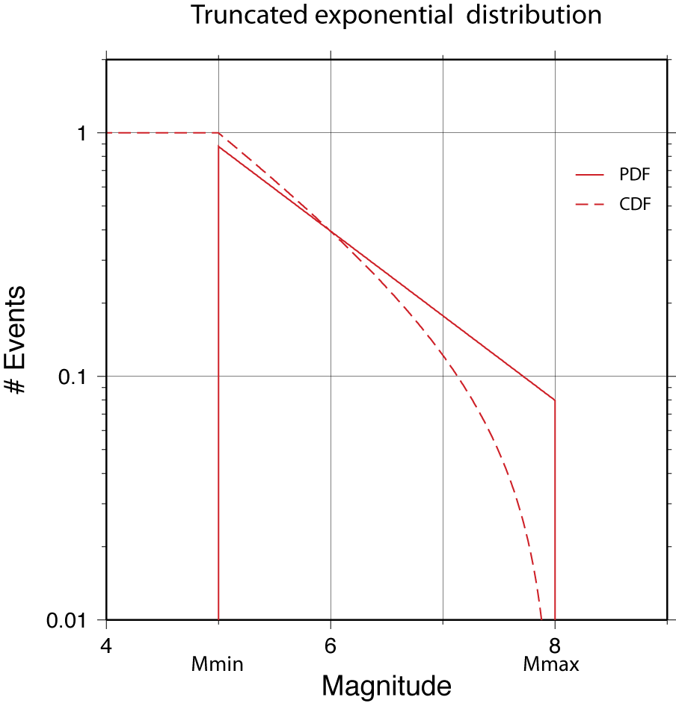 $N\left(M\right)={10}^{a-bM}$

Figure Probability and Cumulative Density Functions for the truncated exponential distribution.

where *N(M)*, the cumulative distribution function (CDF), is the number of earthquakes with magnitude larger than *M*. A more convenient notation is to express the G-R relations in exponential form:

$$N\left(M\right)=e^{α-βM}$$

where

$α=a\ln\left(10\right)$ and $β=b\ln\left(10\right)$.

The (normalized) probability density function (PDF) is:

$$n\left(M\right)=βe^{-βM}$$

The G-R is often referred to as the exponential distribution. Whereas the original formulation was defined for events with M > 0, the distribution is often used in truncated form. The main reason for an upper magnitude bound is that for any finite source there is presumably an associated maximum magnitude, often defined using the maximum dimensions of the source and source scaling relations (e.g. Well and Coppersmith, 1994; Papazachos et al., 2004 The lower bound is often chosen as a cut-off below which events are not of interest for the particular hazard being analyzed. In earthquake hazard, this is often chosen at M=5, but for tsunami hazard, this bound should probably be at M=6.5 for sources that are very close to the site, to M=7.5-8 for very distant sources.

The PDF for the (doubly) truncated exponential distribution (Figure 2) can be derived by substituting *M* with (*M-Mmin*) and re-normalizing the original:

$$n\left(M\right)=β\frac{e^{-β(M-Mmin)}}{1-e^{-β(Mmax-Mmin)}}$$

The CDF for the truncated exponential distribution can then be obtained by integrating the PDF between *Mmin* and *M* and multiplying with the total number of events with *M > Mmin (N(Mmin)):*

$$N\left(M\right)=N\left(Mmin\right).\int_{m=Mmin}^{M}{n\left(m\right)dm}$$

$$=N\left(Mmin\right).\left[1-\frac{1-e^{-β(M-Mmin)}}{1-e^{-β(Mmax-Mmin)}}\right]$$

### Maximum Magnitude model

This is a simple normal distribution around a maximum magnitude, which is usually constrained by the dimensions of the fault, but may also be defined by the size of historic earthquakes. Note that in this case the maximum magnitude is not the upper truncation of the distribution, but the center of the peak of the distribution.

The PDF (Figure 3) is a normal distribution:

$$n\left(M\right)= \frac{1}{\sqrt{2π}σ}e^{-\frac{{(M-Mmax)}^{2}}{2σ^{2}}}$$

The normal distribution is unbounded, so for practical purposes we apply bounds as with the truncated exponential distribution. Since the width of this distribution is defined by a standard deviation, which typically comes from a scaling relation, it is more convenient to choose the upper bound in terms of the number of standard deviations away from the mean (*Mmax*). For a lower bound, it is often sufficient to choose the magnitude below which we expect no contributions to the hazard.

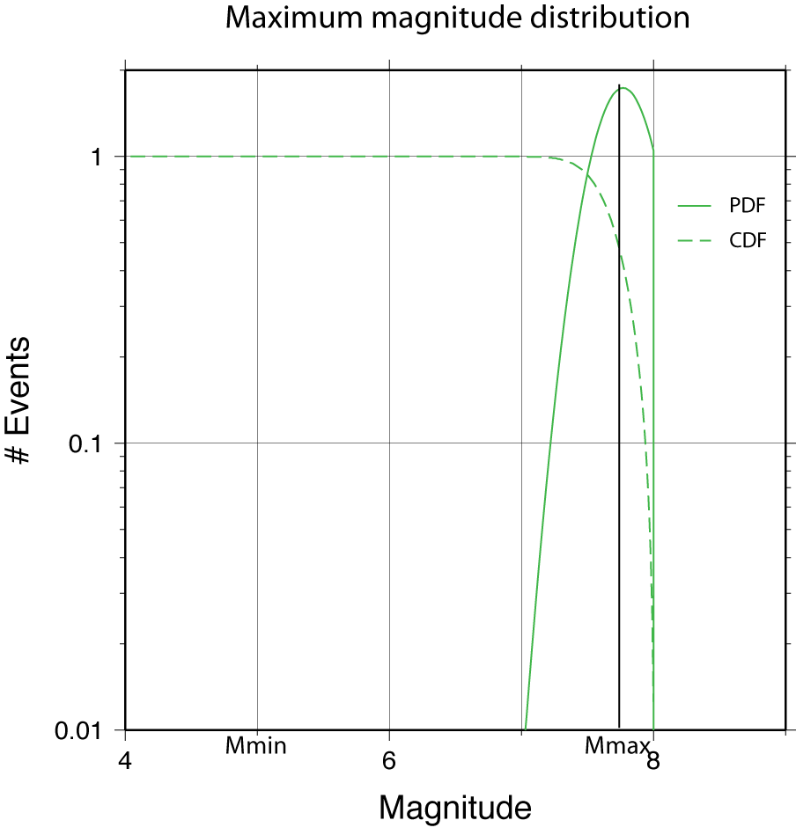

Figure PDF and CDF for the maximum magnitude distribution.

Since there is no closed form solution to for CDF, we use the following polynomial approximation:

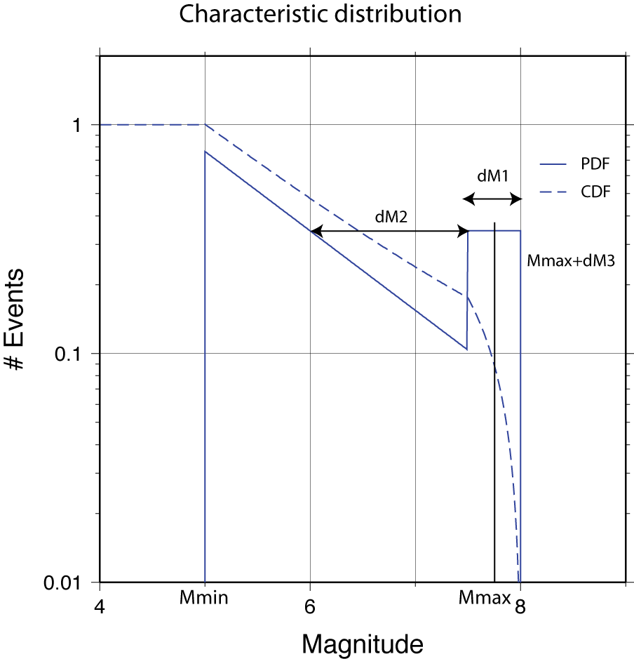 $N\left(M\right)=N\left(Min\right). \left(1-\frac{1}{2{(1+\sum_{i=1}^{6}{c_{i}s)}}^{16}}\right)$

Figure PDF and CDF for the characteristic distribution.

with , *c1* = 0.049867347, *c2* = 0.0211410061, *c3* = 0.0032776263, *c4* = 0.0000380036, *c5* = 0.0000488906, and *c6* = 0.0000053830.

### Characteristic Magnitude model

This relationship was developed in the 1980’s based on paleo-seismic observation on several large faults where it appears that the rate of large earthquakes is much larger than is predicted by a G-R relation. The current model form of this distribution consists of two parts; a truncated exponential distribution below a certain magnitude threshold, and a flat (platform) distribution above this threshold (Figure 4).

It appears that the characteristic model is more appropriate when describing the seismicity on individual faults whereas the Gutenberg-Richter relation is more applicable to areal source regions, or ensembles of multiple source zones. The PDF of the characteristic model can be expressed as:

$$n\left(M\right)=β\frac{e^{(M-Mmin)}}{1-e^{-β(Mmax-Mmin)}}, if Mmin < M < M_{1}$$

$$n(M)= constant, if M_{1} < M < Mmax$$

The CDF is shown in Figure 4. Care must be taken to ensure that the reference magnitude for the upper plateau (indicated by dM2) does not end up being lower than Mmin.

# Variability

An fundamental property of a probabilistic hazard analysis is the inclusion of uncertainties in the underlying models (both source and propagation) into the final result itself. We distinguish between two types of uncertainties: aleatory and epistemic, which belong to a frequency and degree of belief approach to probability respectively.

## Aleatory variability

Aleatory uncertainties, in a strict sense, reflect the inability to predict the outcome of a process due to its random nature. Whether or not an uncertainty in the outcome of a process is a true aleatory uncertainty, i.e., caused by the random behavior of nature rather than a limited understanding of the process itself, is not always clear, and can even differ from one researcher to the other. Aleatory uncertainties are typically accounted for by the use of distribution functions rather than single mean or median values to express the outcome of a process. The probability of an outcome being in a certain range is then given by the area under the probability density (or distribution) function. In our analysis we have identified three main contributions to the aleatory uncertainty: modeling uncertainty (A), uncertainty in geometry (D), and uncertainty to random slip distribution (S).

### Modeling Uncertainty

Under modeling uncertainty we include the mismatch, given known source parameters, between observed and computed tsunami waveforms. Several different sources contribute to this modeling uncertainty, the two most important being errors from the numerical implementation (i.e., our finite difference scheme) and errors from shortcomings in the bathymetric model (either errors in the model, or insufficient resolution). We have estimated this uncertainty by modeling several large and well-constrained tsunamis along the California coast, including the 1960 Chile, 1964 Alaska, and 2006 Kurile events, and by comparing the observed and computed maximum waveheights or run-ups. The resulting standard deviations (A) for coarse and fine grids are 0.595 and 0.345 (natural log), respectively. The bias in the fine grid computations is negligible, and for the individual events are distributed around zero. For the coarse grid, there is a positive bias in all simulations, but this will be eliminated once we compute the inundation hazard using the fine grids. The recent Tohoku an Maule earthquakes will most likely give us a much larger dataset to determine modeling uncertainties given the strong constraints, in particular for Tohoku, on the source model.

### Dip Uncertainty

Since the variations in dip have a direct impact on the vertical deformation of the seafloor and thus the height of the resulting tsunami, we have included this as a separate term in our analysis. Also, since our offshore waveheight hazard is based on pre-computed Green’s functions, which have a fixed dip at the source, we include here uncertainties in the overall dip of the source, which would normally be included as an epistemic uncertainty. That approach would necessitate the computation of a multitude of Green’s functions over the current set, which may make this analysis too expensive in terms of computation time and storage. If we choose to determine a single distribution function that represents the effects of dip variation by modeling scenario waveforms for a distribution of the dip angles around a mean (10 degree dip, with a standard deviation of 5 degrees) it results in a standard deviation (D) of 0.292.

### Slip Variability

We computed S in the same way as the contribution from the dip variations, by iterating over a large number of different slip distributions with equal magnitude. Although our Green’s function approach allows us to include slip variability directly into the hazard computations, we may choose to include this effect as a sigma term, since (a) the slip variability is really an aleatory uncertainty and (b) in order to sample the distribution sufficiently, we would probably have to iterate over a large number of slip distributions for every singe source in our event set. In that case, the resulting S is 0.256.

### Total Sigma and Epsilon Truncation

Based on the aforementioned sigma terms we compute a total sigma using (assuming the uncertainties are un-correlated):

.

The offshore waveheight is computed using a coarse grid and it would therefore follow that the coarse grid version of A should be used to compute the total standard deviation. However, as we will be using the offshore waveheights only as an intermediate step to compute the final waveheight and inundation using the fine grids, using the fine-grid sigma seems more appropriate. The total sigma is therefore 0.519.

Because of the unbounded nature of the normal distribution it is common in seismic hazard analysis to truncate the distribution at a certain number of standard deviations (epsilon). A typical value for epsilon truncation is 3, i.e., we don’t allow for ground motions (or in our case waveheights) that are more than three times the standard deviation away from the mean, where the mean in tsunami hazard is the modeled maximum waveheight for a particular scenario at a particular location.

## Epistemic uncertainties

As already mentioned, uncertainties due to an incomplete understanding of natural processes, which require us to use judgment to quantify, are called epistemic uncertainties, and the way these uncertainties are incorporated is fundamentally different than the way aleatory uncertainties are included. In our analysis, the following uncertainties are deemed epistemic:

* Fault segmentation (single or multi-segment ruptures)
* Slip rate (actual slip rate or fraction of slip seismogenic slip rate)
* Recurrence model (use maximum magnitude or Gutenberg-Richter model, slip rate based versus direct earthquake recurrence rate)

In principal, the epistemic uncertainties should only include those parameters for which a subjective judgment is made, and different logic tree branches represent different understanding of the same process. For instance, large fault may have ruptured along different segments in the past, and some may argue that this segmentation represents a fundamental property of the fault and therefore only segmented ruptures are allowed. Others might argue that there is no compelling reason why the fault cannot rupture in multi-segment ruptures, and in their opinion multi-segment ruptures are allowed. In such case, we can define (at least) two weighted logic tree branches whose weights are chosen to represent the likelihood that a branch represents the correct behavior of the fault, with the weights adding up to one.

In practice, the distinction between epistemic and aleatory uncertainties is not always clear, and for convenience’ sake aleatory uncertainties are sometimes incorporated through logic tree branches, i.e. as epistemic uncertainties. This usually does not affect the mean hazard, but it will affect fractile results.

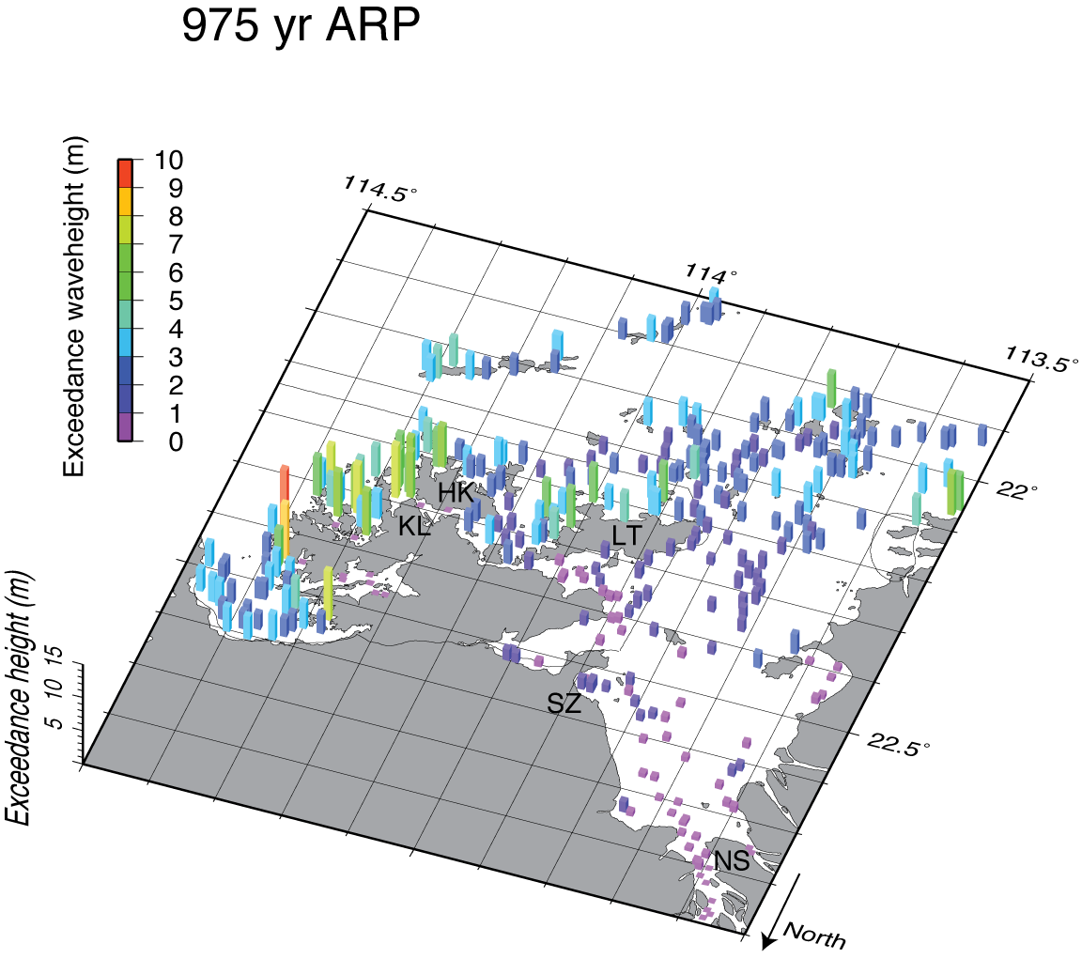

Figure Example of Probabilistic offshore waveheights, output from Tsunprob_haz.

### Logic Trees

The discrete nature of the epistemic uncertainties is expressed through the use of logic trees, where all the different manifestations of a process are represented as a branch of a logic tree.

Uncertainties in the model parameters are generally incorporated using a logic-tree approach, where different alternatives are represented as weighted branches. These include variations in slip-rate, magnitude range and distribution, fault geometry, as well as rake. As already mentioned, dip variations would normally also be considered under the epistemic uncertainties, but because these would require a new set of Green’s functions, we have added them as an aleatory uncertainty.

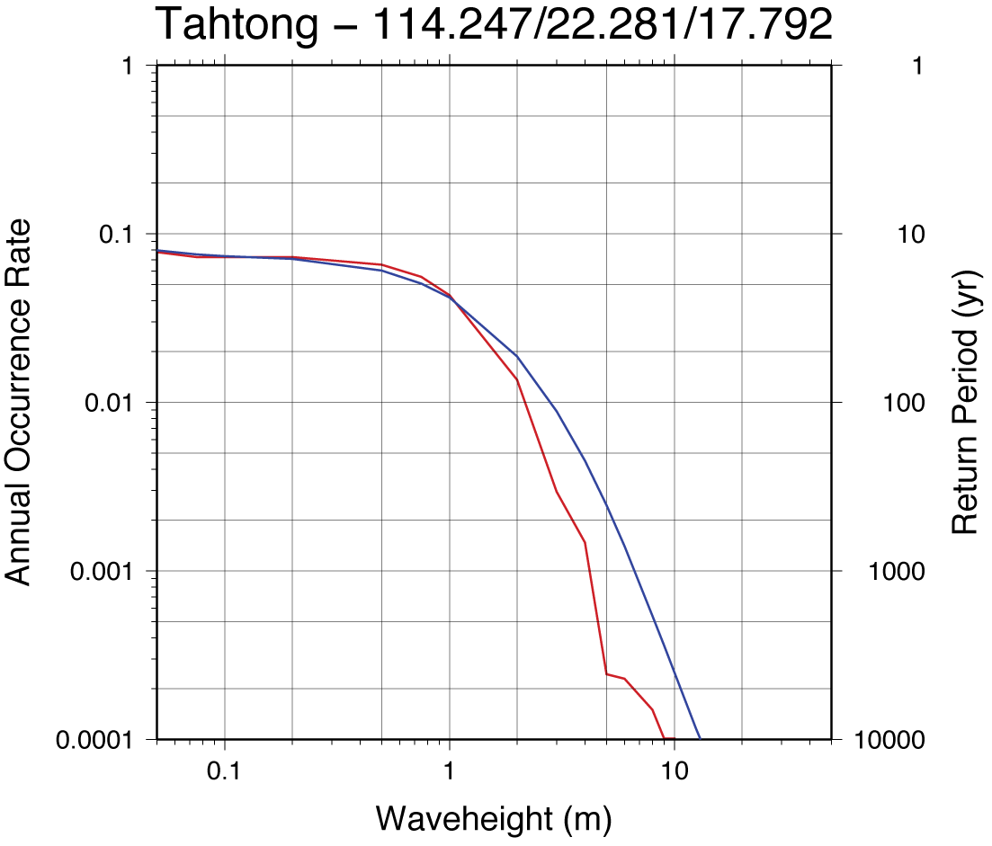

Figure Example of a probabilistic offshore waveheights hazard curve. Output from Tsunprob_haz in file named H-****. The red curve shows the hazard without aleatory uncertainty, the blue with aleatory uncertainty.

In the Green’s function approach, it is convenient to divide these uncertainties into two groups: parameter variations that act on the Green’s function level (e.g., fault geometry) and parameters that do not influence the Green’s functions, such as the recurrence parameters and magnitude scaling relations. In the latter case, the logic tree branches are easily added without major computational requirements, but for the former, the question is whether any extra branch in the logic tree, such as a variation in slip, would require an entire set of Green’s functions. From some simple numerical experiments, we conclude that in many cases, especially at large distances, these variations can accurately be taken into account by perturbing the Green’s functions using a constant scaling factor rather than re-computing them. For example, a change in rake, readily translates into a change of the vertical seafloor displacement, which in turn directly translate to differences in waveheight.

At shorter distances, i.e., local faults, this approach is less accurate, and in these situations (particularly for dip-slip events) we will have to resort to complete re-computation of the Green’s functions. However, since these sources are relatively scarce, and require less computing time due to the short distances, this is far less of a burden than having to re-compute tele-tsunami Green’s functions.

# Programs

A short description of all the programs included in this set and shown in Figure 1.

## Source excitation

### *grid3*

grid3 computes a simple grid of subfaults based on a surface trace of the rupture, dip, and bottom of the rupture (Appendix A-1). The grids are represented as rectangular fault elements (subfaults), each with uniform slip. The code expects to find an input file called: *rupture.detailed*, which contains the surface trace of the fault source broken up into segments. The output file is named i_invall-*faultname*, and is used as input for both the probabilistic code Hazts and the generation of the Green’s functions (Figure 1).

### *edgrn*

From Wang et al. (2003), computes the fundamental static Green’s functions, using wavenumber integration, that are used as input to static-ed (Appendix A-5). These Green’s functions typically need to be calculated only once for a characteristic crustal model and are used by static-ed to compute surface deformation for slip on a plane.

### *static-ed*

Based on *edstat* (Wang et al 2003), computes the static deformation field (z, n, e) from a list of subfaults (i_invall-*). It requires the output from *edgrn* in the working directory (Appendix A-6). The output file is a binary grid of deformation values and can easily be converted into GMT-compatible NetCDF format as shown in Appendix A-6.

## Tsunami code

### *cnltsunami*

The main code to compute tsunami waves based on the code of Satake (1995), non-linear with moving boundary condition (inundation). The code can use nested grids to allow for high resolution computations in targeted areas. The step down in grid spacing has to occur with odd factors (e.g. 120 arcsec -> 40 arcsec -> 8 arcsec) and it is recommended to bridge large reduction using a number of intermediate steps with grid spacing reductions of 3 or 5 at most. Also, make sure that there are several grid gridpoints between the outer boundary of a nested grid and the inner boundary (with the next grid). Care should be taken that the mother and child grids have common boundary points and are not offset from each other. Detailed instructions are given in Appendix A-7. Care must be taken with this code to avoid numerical instabilities. In many cases these will rapidly blow up and cause the code to halt, but in some cases these instabilities can lead to unreasonably large waveheights (say 100 m for a few meters of slip) without completely blowing up. It is therefore important to check the output waveheight map for these occurrences. The GMT command *grdinfo* is particularly useful in this context. In general, smaller grid spacings require smaller timestep, but it’s not possible to give a unique relationship between the two for the non-linear code.

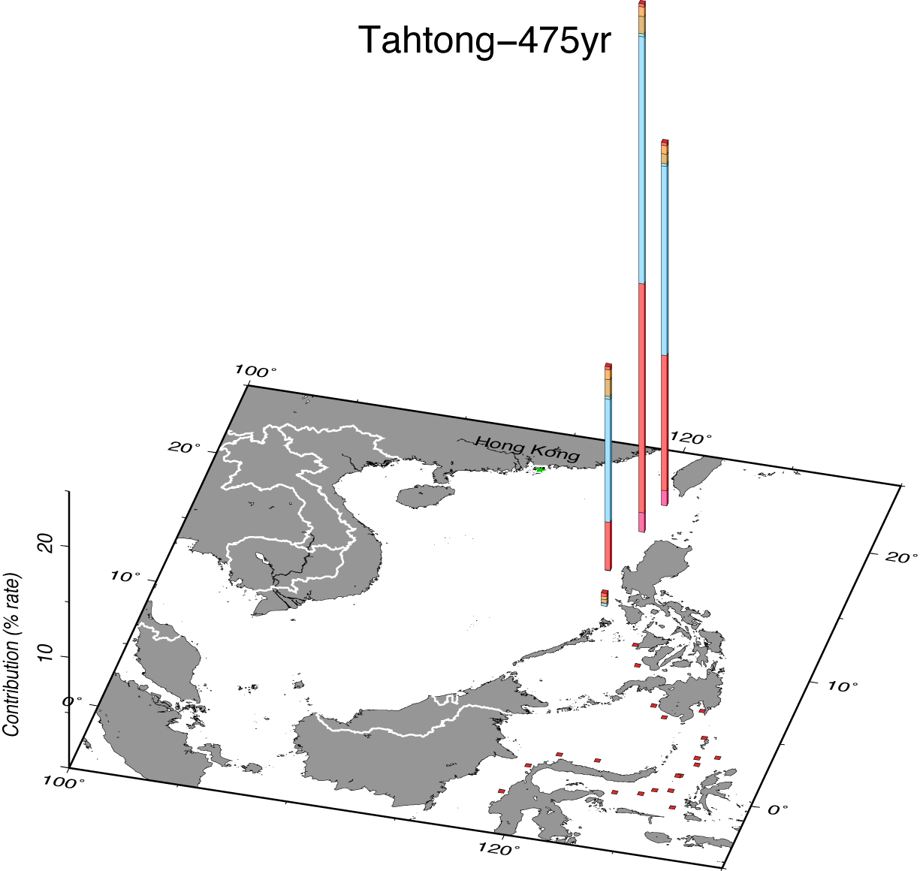

Figure Example offault segment disaggregation, output from Tsunprob_haz, file type S-****.

The linear algorithm is much more stable, and in case of doubt it’s always prudent to re-run the problem linearly (Appendix A-7) and compare the results to the non-linear code. They should not differ significantly for offshore waveheights.

## Probabilistic analysis

### *Hazts*

Code to compute the probabilistic set of scenarios (i_multimux-*faultname*). This code (Appendix A-2) reads the input source model and performs the probabilistic integration over magnitude, source location, and the various epistemic branches, and generates a set of scenarios (typically hundreds to thousands of scenarios), which comprise the probabilistic distribution of events. The output in the i_multimux-*faultname* can be used to check the computed earthquake rates to the rates that are expected (from the input).

### *Tsunprob_dmx2*

Using the output from Hazts (i_multimux-*faultname*, and the multiplexed files from cnltsunami, this code computes the maximum waveheights for all the points for which Green’s functions have been computed for every scenario (Appendix A-3). For every point, a separate file is created which list the maximum waveheight for every event with the corresponding rate of occurrence. For large problems (tens of thousands of events), this code takes several hours to finish.

### *Tsunprob_haz*

Computes exceedance waveheights for different return periods based on the waveheight and rate output from *Tsunprob_dmx2* (see Appendix A-4)*.* At this stage, the results for all the different sources are combined (see Figure 1). The output consists of exceedance waveheights at every point for different return periods (stdout, Figure 5), a set of files with the hazard curves for every location (H-****, Figure 6), subfault disaggregation for every point (D-****), segment and epsilon disaggregation at every point (S-****, Figure 7). All these files are in ASCII format and can easily be inspected. It is not uncommon for several location to produce NaN results. This is usually due to the fact the actual location of the point ended up being on-land, so that the waveheights are not defined.

## Post-processing

We use the Generic Mapping Tools (GMT) to process the data and plot the results. In Appendix B we present several scripts used to create the plots shown in this manual. The GMT package (and NetCDF) needs to be downloaded and installed separately from this package.

# References

Baba, T, Cummins, P.R., Thio, H.K., and Tsushima, H., 2008. Validation and joint inversion of teleseismic waveforms for earthquake source models using deep ocean bottom pressure records: A case study of the 2006 Kuril megathrust earthquake, Earth Plan. Sc. Lett., in press.

Burbidge, D., Cummins, P.R., Mleczko, R. and Thio, H.K., 2008. A Probabilistic Tsunami Hazard Assessment for Western Australia, Pure and Applied Geophysics, in press.

Fujii, Y., and K. Satake (2006), Source of the July 2006 West Java tsunami estimated from tide gauge records, Geophys. Res. Lett., 33, L24317, doi:10.1029/2006GL028049.

Geist, E.L., and Parsons, T., 2006, Probabilistic analysis of tsunami hazards: Natural Hazards, v. 37, p. 277–314

Ichinose, G., P. Somerville, H. K. Thio, R. Graves, and D. O'Connell (2007), Rupture process of the 1964 Prince William Sound, Alaska, earthquake from the combined inversion of seismic, tsunami, and geodetic data, J. Geophys. Res., 112, B07306, doi:10.1029/2006JB004728.

Papazachos, B.C., Scordilis, E.M., Pangiatopoulos, D.G., Pazazachos, C.B. and Karakaisis, G.F., 2004. Global relations between seismic fault parameters and moment magnitude of earthquakes, Bull. Geol. Soc, Greece, XXXVI, 482,1489.

McGuire, R.K., 2004. Seismic hazard and Risk Analysis, Earthquake Engineering Reseatch Institute Monograph no. 10, 221 pp.

Satake, K., 1995. Linear and Nonlinear Computations of the 1992 Nicaragua earthquake tsunami, *Pageoph*, 144, 455-470.

Schwartz, D. P., and K. J. Coppersmith, 1984, Fault Behavior and Characteristic Earthquakes: Examples From the Wasatch and San Andreas Fault Zones, *J. Geophys. Res.*, *89* (B7), 5681–5698, doi:10.1029/JB089iB07p05681

Schwartz, D. P., K. J. Coppersmith, F. H. Swan III, P. Somerville, and W. U. Savage, 1981. Characteristic earthquakes on intraplate normal faults (abstract), *Earthquake Notes*, 52, 71.

Thio, H.K., Somerville, P., and Polet, J. (2010). Probabilistic Tsunami Hazard in California. Pacific Earthquake Engineering Research Center, PEER Report 2010/108, University of California, Berkeley.

Titov, V.V., and C.E. Synolakis, 1996. Numerical modeling of 3-D long wave runup using VTCS-3. In *Long Wave Runup Models*, P. Liu, H. Yeh, and C. Synolakis (eds.), World Scientific Publishing Co. Pte. Ltd., Singapore, 242–248.

Vick, S., G., 2002. Degrees of Belief: Subjective Probability and Engineering Judgment, ASCE Press, 455 pp.

Wang, R, F. Lorenzo-Martín and F. Roth, 2003. Computation of deformation induced by earthquakes in a multi-layered elastic crust—FORTRAN programs EDGRN/EDCMP, Computers & Geosciences, 29, 195–207.

Wang, R, F. Lorenzo-Martín and F. Roth, 2006. Erratum to: “Computation of deformation induced by earthquakes in a multi-layered elastic crust—FORTRAN programs EDGRN/EDCMP”, Computers & Geosciences, 32, 1817.

Appendix A: Annotated sample input and output files

A-1 Grid3

Input to grid3:

|  |  |
| --- | --- |
| **rupture.detailed** | |
| 1 | manila |
| 2 | 1 15 90 |
| 3a | 120.25 13 |
| 3b | 119.125 13.75 |
| 2 | 2 15 90 |
| 3a | 119.125 13.75 |
| 3b | 119.125 18.25 |
|  | 3 15 90 |
|  | 119.125 18.25 |
|  | 120.5 20.0 |
|  | 4 15 90 |
|  | 120.5 20.0 |
|  | 120.0 22.5 |

1 – faultname (no spaces)

2 – header for first set of points of the surface trace: number of the section dip rake

3 – a: longitude and latitude of first point

b: longitude and latitude of second point

2 and 3 are repeated for as many points there are on the trace. The first point of a section does not need to coincide with the last point of the previous, in which case the fault will be discontinuous.

*grid3* expects a file named *rupture.detailed* to exist in the current working directory.

It will ask for input regarding top and bottom of the fault.

*Example run (user input in italics):*

|  |
| --- |
| > *grid3* |
| Subfault length and width? |
| *50 50* |
| Depth of bottom of rupture? |
| *50* |

Its output is called *i_invall-faultname*

|  |  |
| --- | --- |
| **i_invall-manila** | |
| *1* | Manila |
| *2* | 5 |
| *3* | 120.2500 13.0000 0.00 15.0 |
|  | 119.1250 13.7500 0.00 15.0 |
|  | 119.1250 18.2500 0.00 15.0 |
|  | 120.5000 20.0000 0.00 15.0 |
|  | 120.0000 22.5000 0.00 15.0 |
| *4* | 48 0 0 0 0 |
| *5* | 120.1863 13.3068 6.47 -55.4 15.0 90.0 100.00 50.00 50.00 1 1 1 |
|  | 120.4404 13.6649 19.41 -55.4 15.0 90.0 100.00 50.00 50.00 1 2 1 |
|  | 119.8047 13.5618 6.47 -55.5 15.0 90.0 100.00 50.00 50.00 2 1 1 |
|  | 120.0589 13.9201 19.41 -55.5 15.0 90.0 100.00 50.00 50.00 2 2 1 |
|  | 119.4222 13.8163 6.47 -55.6 15.0 90.0 100.00 50.00 50.00 3 1 1 |
|  | 119.6761 14.1750 19.41 -55.6 15.0 90.0 100.00 50.00 50.00 3 2 1 |
|  | 119.3492 13.9751 6.47 0.0 15.0 90.0 100.00 50.00 50.00 4 1 2 |
|  | 119.7976 13.9743 19.41 0.0 15.0 90.0 100.00 50.00 50.00 4 2 2 |
|  | 119.3496 14.4256 6.47 0.0 15.0 90.0 100.00 50.00 50.00 5 1 2 |
|  | 119.7989 14.4247 19.41 0.0 15.0 90.0 100.00 50.00 50.00 5 2 2 |
|  | 119.3501 14.8760 6.47 0.0 15.0 90.0 100.00 50.00 50.00 6 1 2 |
|  | 119.8003 14.8751 19.41 0.0 15.0 90.0 100.00 50.00 50.00 6 2 2 |
|  | 119.3506 15.3265 6.47 0.0 15.0 90.0 100.00 50.00 50.00 7 1 2 |
|  | 119.8017 15.3256 19.41 0.0 15.0 90.0 100.00 50.00 50.00 7 2 2 |
|  | 119.3511 15.7769 6.47 0.0 15.0 90.0 100.00 50.00 50.00 8 1 2 |
|  | 119.8032 15.7760 19.41 0.0 15.0 90.0 100.00 50.00 50.00 8 2 2 |
|  | 119.3516 16.2274 6.47 0.0 15.0 90.0 100.00 50.00 50.00 9 1 2 |
|  | 119.8047 16.2264 19.41 0.0 15.0 90.0 100.00 50.00 50.00 9 2 2 |
|  | 119.3521 16.6778 6.47 0.0 15.0 90.0 100.00 50.00 50.00 10 1 2 |
|  | 119.8063 16.6768 19.41 0.0 15.0 90.0 100.00 50.00 50.00 10 2 2 |
|  | 119.3526 17.1283 6.47 0.0 15.0 90.0 100.00 50.00 50.00 11 1 2 |
|  | 119.8079 17.1272 19.41 0.0 15.0 90.0 100.00 50.00 50.00 11 2 2 |
|  | 119.3532 17.5787 6.47 0.0 15.0 90.0 100.00 50.00 50.00 12 1 2 |
|  | 119.8096 17.5777 19.41 0.0 15.0 90.0 100.00 50.00 50.00 12 2 2 |
|  | 119.3538 18.0291 6.47 0.0 15.0 90.0 100.00 50.00 50.00 13 1 2 |
|  | 119.8114 18.0281 19.41 0.0 15.0 90.0 100.00 50.00 50.00 13 2 2 |
|  | 119.4503 18.3022 6.47 36.4 15.0 90.0 100.00 50.00 50.00 14 1 3 |
|  | 119.8185 18.0435 19.41 36.4 15.0 90.0 100.00 50.00 50.00 14 2 3 |
|  | 119.7330 18.6644 6.47 36.4 15.0 90.0 100.00 50.00 50.00 15 1 3 |
|  | 120.1018 18.4054 19.41 36.4 15.0 90.0 100.00 50.00 50.00 15 2 3 |
|  | 120.0168 19.0260 6.47 36.5 15.0 90.0 100.00 50.00 50.00 16 1 3 |
|  | 120.3859 18.7665 19.41 36.5 15.0 90.0 100.00 50.00 50.00 16 2 3 |
|  | 120.3019 19.3872 6.47 36.6 15.0 90.0 100.00 50.00 50.00 17 1 3 |
|  | 120.6713 19.1271 19.41 36.6 15.0 90.0 100.00 50.00 50.00 17 2 3 |
|  | 120.5882 19.7479 6.47 36.7 15.0 90.0 100.00 50.00 50.00 18 1 3 |
|  | 120.9580 19.4872 19.41 36.7 15.0 90.0 100.00 50.00 50.00 18 2 3 |
|  | 120.6844 20.2609 6.47 -10.5 15.0 90.0 100.00 50.00 50.00 19 1 4 |
|  | 121.1409 20.3387 19.41 -10.5 15.0 90.0 100.00 50.00 50.00 19 2 4 |
|  | 120.5975 20.7038 6.47 -10.5 15.0 90.0 100.00 50.00 50.00 20 1 4 |
|  | 121.0552 20.7818 19.41 -10.5 15.0 90.0 100.00 50.00 50.00 20 2 4 |
|  | 120.5100 21.1468 6.47 -10.5 15.0 90.0 100.00 50.00 50.00 21 1 4 |
|  | 120.9691 21.2250 19.41 -10.5 15.0 90.0 100.00 50.00 50.00 21 2 4 |
|  | 120.4220 21.5897 6.47 -10.5 15.0 90.0 100.00 50.00 50.00 22 1 4 |
|  | 120.8825 21.6681 19.41 -10.5 15.0 90.0 100.00 50.00 50.00 22 2 4 |
|  | 120.3336 22.0326 6.47 -10.6 15.0 90.0 100.00 50.00 50.00 23 1 4 |
|  | 120.7953 22.1112 19.41 -10.6 15.0 90.0 100.00 50.00 50.00 23 2 4 |
|  | 120.2445 22.4755 6.47 -10.6 15.0 90.0 100.00 50.00 50.00 24 1 4 |
|  | 120.7077 22.5543 19.41 -10.6 15.0 90.0 100.00 50.00 50.00 24 2 4 |

*1* – name of the rupture

*2* – number of sections in the original rupture.detailed file (+1)

*3* – longitude and latitude of section boundaries

*4* – number of subfaults in the rest of the file (ignore the zeros)

*5* - long, lat, depth, strike, dip, rake, slip, length, width, subfault number, downdip sequence number, along strike sequence number, section number

A-2 Hazts

The_invall-*faultname* file is one of the input files for the code Hazts, used to determine the probabilistic scenario set. The other two input files are:

|  |  |
| --- | --- |
| **i_Hazts** | |
| *1* | Hazts_SouthChinaSea.flt |
| *2* | South_China_Sea |
| *3* | out1 |

*1* – filename of the source file

*2* – name of the problem

*3* – test output file

and the third file contains the entire fault recurrence model:

|  |  |  |
| --- | --- | --- |
| **Hazts_manila.flt** | | |
| *1* | 1 | iCoor (0=(x,y), 1=(long,lat) |
| *2* | 1 | # Flts |
| *3* | manila |  |
| *4* | 1.0 | Prob Activity |
| *5* | 1 | nSeg model |
| *6* | 1 1.0 | nFlt segments, wt |
| *7* | manila |  |
| *8* | 10 1 0. 1 0 | Source type, atten type, sampleStep (km), fltdirect, synchron |
| *9* | 1.0 | Aleatory seg wt |
| *10* | i_invall-manila |  |
| *11* | 0 0 0 0 | Segment limit (along strike min max, along dip min max) |
| *-* | 1 | Number of dip variations |
| *-* | 0. | Dip variations |
| *-* | 1.0 | Wt for dip variations |
| *12a* | 1 | Number of b-values |
| *12b* | 0.90 | b-values |
| *12c* | 1. | Weights for b-values |
| *13a* | 1 | Number of slip-rates |
| *13b* | 25 | Slip rates (mm/yr) |
| *13c* | 1. | Weights for slip rates |
| *14a* | 1 | nRecur |
| *14b* | 3 | Recur model (0 = char model, 1=exponential, 3 = max mag) |
| *14c* | 1. | Recurrence model weights |
| *14d* | 0.25 0.2 0.25 | Delta_M1 and delta_M2 for char. mag. recur. relationship |
| *15a* | 1 | Number of fault widths |
| *15b* | 26. | Fault thickness |
| *15c* | 1.0 | Weights for fault thickness |
| *16* | 1 | Overridemag option |
| *17a* | 3 | Number of maximum magnitudes |
| *17b* | 7.8 8.2 9.0 | Maximum magnitudes |
| *17c* | 0.5 0.3 0.2 | Weights for max mag |
| *18* | 7.5 0.25 50. 50. 1 1 3.0 | minmag, magstep, hxStep, hzStep, nRupArea, nRupWidth, minDepth |
| *19* | 1 |  |
| *20a* | -3.99 0.98 0.21 | rupArea: a, b, sigma in log10 units W&C all |
| *20b* | -1.61 0.41 0.15 | rupWidth: a, b, sigma in log10 units W&C all |
| *21* | 1 | ftype |

Green highlights indicate the parameters are currently in use.

*1* – Should be 1 for now (geographic coordinates)

*2* – Number of fault systems

*3* – name of the fault system

*4* – probability (0-1) of the fault being active (often 1.0)

*5* – number of different segmentation models for this fault

*6* – number of faults for this segmentation model, weight of this segmentation model

*7* – name of first fault in this segmentation model

*8* – source type (should always be 10)

*9* – aleatory weight for this fault (usually 1.0)

*10* – input file with the entire rupture model

*11* – segment limit (in i_invall file: min max (index # along strike), min max (index # along dip)

*12* – logic tree for b-values: 12a – number of b-values, 12b – b-values, 12c – weights for the different b-values

*13* – logic tree for slip rates (13a,b,c same kind of input as in 12a,b,c, depending on the recurrence model (14), this number is interpreted as either:

maximum magnitude model - actual slip rate (mm/yr), or, if negative, return time in years

characteristic model - slip rate

G-R model – slip rate, or, if negative, number of events with magnitude larger than Mmin

*14* – recurrence models, with a similar kind of input as in 12a,b,c

0 – characteristic model

1 – G-R model

3 – maximum magnitude

*15* – logic tree branches for vertical fault width, see 12a,b,c for branch and weight specification

*16* – if 0, program will determine maximum magnitude from scaling relations, if 1, maximum magnitudes are input manually (recommended to use manual option)

*17* – logic tree branches for Mmax, see 12a,b,c for branching and weighting

*18* – Mmin (when changing this, make sure that you don’t have to change the slip rate in the case of G-R relation with number of events specified.

*20* – scaling relations

We run Hazts as follows (make sure that i_invall-*faultname* exists in the working directory:

|  |
| --- |
| > *Hazts* |
| ******************************* |
| * Tsunami hazard code * |
| * v2.0 - August, 2007 * |
| * Written by Hong Kie Thio * |
| * Based on Haz_main by NAA * |
| * v2.1 - November 5, 2007 * |
| * Added output for fractiles* |
| * Re-included URS output * |
| * as option * |
| ******************************* |
|  |
| Enter the input file name. |
| *i_Hazts* |
| nflt = 1 |
| 1 manila |
| sfName(iFlt) manila |

A-3 Tsunprob_dmx2

The output from Hazts is a list of probabilistic scenarios in the file i_multimux-*faultname*

|  |  |
| --- | --- |
| **i_multimux-manila** | |
| 1 | Manila |
| 2 | 3 P-manila-00000 7.875 252.031 100.000 0.000 0.241040E-11 |
| 3 | mux/manila-0000-mux 0.252031E+01 0.729110E-03 0.787500E+01 1 |
|  | mux/manila-0002-mux 0.252031E+01 0.729110E-03 0.787500E+01 3 |
|  | mux/manila-0004-mux 0.252031E+01 0.729110E-03 0.787500E+01 5 |
|  | . |
|  | . |
|  | . |
|  | . |
|  | . |
|  |  |
| 2 | 46 P-manila-00194 9.375 2034.130 1150.000 100.000 0.277473E-04 |
| 3 | mux/manila-0002-mux 0.203413E+02 0.277473E-04 0.937500E+01 3 |
|  | mux/manila-0003-mux 0.203413E+02 0.277473E-04 0.937500E+01 4 |
|  | mux/manila-0004-mux 0.203413E+02 0.277473E-04 0.937500E+01 5 |
|  | mux/manila-0005-mux 0.203413E+02 0.277473E-04 0.937500E+01 6 |
|  | mux/manila-0006-mux 0.203413E+02 0.277473E-04 0.937500E+01 7 |
|  | mux/manila-0007-mux 0.203413E+02 0.277473E-04 0.937500E+01 8 |
|  | mux/manila-0008-mux 0.203413E+02 0.277473E-04 0.937500E+01 9 |
|  | mux/manila-0009-mux 0.203413E+02 0.277473E-04 0.937500E+01 10 |
|  | mux/manila-0010-mux 0.203413E+02 0.277473E-04 0.937500E+01 11 |
|  | mux/manila-0011-mux 0.203413E+02 0.277473E-04 0.937500E+01 12 |
|  | mux/manila-0012-mux 0.203413E+02 0.277473E-04 0.937500E+01 13 |
|  | mux/manila-0013-mux 0.203413E+02 0.277473E-04 0.937500E+01 14 |
|  | mux/manila-0014-mux 0.203413E+02 0.277473E-04 0.937500E+01 15 |
|  | mux/manila-0015-mux 0.203413E+02 0.277473E-04 0.937500E+01 16 |
|  | mux/manila-0016-mux 0.203413E+02 0.277473E-04 0.937500E+01 17 |
|  | mux/manila-0017-mux 0.203413E+02 0.277473E-04 0.937500E+01 18 |
|  | mux/manila-0018-mux 0.203413E+02 0.277473E-04 0.937500E+01 19 |
|  | mux/manila-0019-mux 0.203413E+02 0.277473E-04 0.937500E+01 20 |
|  | mux/manila-0020-mux 0.203413E+02 0.277473E-04 0.937500E+01 21 |
|  | mux/manila-0021-mux 0.203413E+02 0.277473E-04 0.937500E+01 22 |
|  | mux/manila-0022-mux 0.203413E+02 0.277473E-04 0.937500E+01 23 |
|  | mux/manila-0023-mux 0.203413E+02 0.277473E-04 0.937500E+01 24 |
|  | mux/manila-0024-mux 0.203413E+02 0.277473E-04 0.937500E+01 25 |
|  | mux/manila-0025-mux 0.203413E+02 0.277473E-04 0.937500E+01 26 |
|  | mux/manila-0026-mux 0.203413E+02 0.277473E-04 0.937500E+01 27 |
|  | mux/manila-0027-mux 0.203413E+02 0.277473E-04 0.937500E+01 28 |
|  | mux/manila-0028-mux 0.203413E+02 0.277473E-04 0.937500E+01 29 |
|  | mux/manila-0029-mux 0.203413E+02 0.277473E-04 0.937500E+01 30 |
|  | mux/manila-0030-mux 0.203413E+02 0.277473E-04 0.937500E+01 31 |
|  | mux/manila-0031-mux 0.203413E+02 0.277473E-04 0.937500E+01 32 |
|  | mux/manila-0032-mux 0.203413E+02 0.277473E-04 0.937500E+01 33 |
|  | mux/manila-0033-mux 0.203413E+02 0.277473E-04 0.937500E+01 34 |
|  | mux/manila-0034-mux 0.203413E+02 0.277473E-04 0.937500E+01 35 |
|  | mux/manila-0035-mux 0.203413E+02 0.277473E-04 0.937500E+01 36 |
|  | mux/manila-0036-mux 0.203413E+02 0.277473E-04 0.937500E+01 37 |
|  | mux/manila-0037-mux 0.203413E+02 0.277473E-04 0.937500E+01 38 |
|  | mux/manila-0038-mux 0.203413E+02 0.277473E-04 0.937500E+01 39 |
|  | mux/manila-0039-mux 0.203413E+02 0.277473E-04 0.937500E+01 40 |
|  | mux/manila-0040-mux 0.203413E+02 0.277473E-04 0.937500E+01 41 |
|  | mux/manila-0041-mux 0.203413E+02 0.277473E-04 0.937500E+01 42 |
|  | mux/manila-0042-mux 0.203413E+02 0.277473E-04 0.937500E+01 43 |
|  | mux/manila-0043-mux 0.203413E+02 0.277473E-04 0.937500E+01 44 |
|  | mux/manila-0044-mux 0.203413E+02 0.277473E-04 0.937500E+01 45 |
|  | mux/manila-0045-mux 0.203413E+02 0.277473E-04 0.937500E+01 46 |
|  | mux/manila-0046-mux 0.203413E+02 0.277473E-04 0.937500E+01 47 |
|  | mux/manila-0047-mux 0.203413E+02 0.277473E-04 0.937500E+01 48 |

1 – Name of the source

2 – number of subfaults for each event, name of the output file

3 – pathname to subfault Green’s function, slip, probability (rate), magnitude.

We run the Tsunprob_dmx2 code as follows:

|  |
| --- |
| > *Tsunprob_dmx2 < i_multimux-manila* |

For every exposure location, Tsunprob_dmx2 creates one output file, T-xxxx (where xxxx is the location number, sequential from the original input file)

|  |  |
| --- | --- |
| **T-0005** | |
| *1* | 22.548 114.900 6.056 7.7644 |
| *2* | 2.56103e-01 7.29110e-04 7.875 3 1 3 5 |
| *2* | 3.29801e-01 7.29110e-04 7.875 3 2 4 6 |
| *2* | 2.17015e-01 7.29110e-04 7.875 3 3 5 7 |
| *.* | 4.52784e-01 7.29110e-04 7.875 3 4 6 8 |
| *.* | 2.23412e-01 7.29110e-04 7.875 3 5 7 9 |
| *.* | 4.40211e-01 7.29110e-04 7.875 3 6 8 10 |
|  | 2.55601e-01 7.29110e-04 7.875 3 7 9 11 |
|  | 3.48381e-01 7.29110e-04 7.875 3 8 10 12 |
|  | 3.84685e-01 7.29110e-04 7.875 3 9 11 13 |
|  | 4.02602e-01 7.29110e-04 7.875 3 10 12 14 |
|  | 4.24846e-01 7.29110e-04 7.875 3 11 13 15 |
|  | 6.32286e-01 7.29110e-04 7.875 3 12 14 16 |
|  | 4.30250e-01 7.29110e-04 7.875 3 13 15 17 |
|  | 5.08779e-01 7.29110e-04 7.875 3 14 16 18 |
|  | 5.49661e-01 7.29110e-04 7.875 3 15 17 19 |
|  | 4.26314e-01 7.29110e-04 7.875 3 16 18 20 |
|  | 4.38253e-01 7.29110e-04 7.875 3 17 19 21 |
|  | 4.42020e-01 7.29110e-04 7.875 3 18 20 22 |
|  | 5.05904e-01 7.29110e-04 7.875 3 19 21 23 |
|  | 5.26305e-01 7.29110e-04 7.875 3 20 22 24 |
|  | 4.45162e-01 7.29110e-04 7.875 3 21 23 25 |
|  | 7.42463e-01 7.29110e-04 7.875 3 22 24 26 |
|  | 5.62999e-01 7.29110e-04 7.875 3 23 25 27 |
|  | 9.96062e-01 7.29110e-04 7.875 3 24 26 28 |
|  | 8.55157e-01 7.29110e-04 7.875 3 25 27 29 |
|  | 1.46167e+00 7.29110e-04 7.875 3 26 28 30 |
|  | 9.72384e-01 7.29110e-04 7.875 3 27 29 31 |
|  | 1.94308e+00 7.29110e-04 7.875 3 28 30 32 |

*1* – header line: location (lat, lon) and waterdepth of exposure location, 4th number is internal

*2* – one line per scenario: maximum waveheight, rate of ccurrence, magnitude, number of subfaults, subfault index numbers

A-4 Tsunprob_haz

The results from all source zones are combined in the final step, Tsunprob_haz. The input file has the following form:

|  |  |
| --- | --- |
| **i_tsunrob_haz** | |
| *1* | 1023 1 .53 3 |
| *2* | / |
| *3* | manila |
| *.* | negros |
| *.* | halma |
| *.* | moluc |

*1* – number of exposure locations, dummy, total sigma, sigma truncation

*2* – prefix

*3* – source zone (directory, one line for each source zone)

The input file is read from standard input:

|  |
| --- |
| > *Tsunprob_haz < i_tsunprob_haz > o_amp* |

And several different kinds of output files are created. The most important are the probabilistic exceedance waveheights which are written to standard output (and redirected to o_amp in the above example). The structure of that file is:

|  |  |
| --- | --- |
| *1* | 0.72000E+02 0.47500E+03 0.97500E+03 0.24750E+04 0.10000E+05 |
| *2* | 114.929 22.640 1.053 0.46818E+01 0.11581E+02 0.14743E+02 0.19999E+02 0.38581E+02 |
| *.* | 114.911 22.607 7.808 0.29751E+01 0.73921E+01 0.92301E+01 0.12461E+02 0.21690E+02 |
| *.* | 114.920 22.575 4.004 0.29703E+01 0.86146E+01 0.11550E+02 0.16130E+02 0.26787E+02 |

*1* – return periods (years) corresponding to columns 4-8

*2* – location (lon lat) and depth at exposure location, exceedance waveheights for the 5 different return periods in row 1.

Other output files contain information per exposure location (sequentially numbered):

Hazard curves (e.g. H-0002, for exposure point number 3):

|  |  |
| --- | --- |
| **H-0002** | |
| *1* | 0.00000 0.269672E+00 0.271744E+00 |
| *.* | 0.01000 0.145204E+00 0.140862E+00 |
| *.* | 0.02000 0.122986E+00 0.121072E+00 |
| *.* | 0.05000 0.863382E-01 0.895087E-01 |
| *.* | 0.07500 0.759384E-01 0.803355E-01 |
| *.* | 0.10000 0.732890E-01 0.763942E-01 |
| *.* | 0.20000 0.726541E-01 0.727145E-01 |

*1* – exceedance wavehwight, rate of exceedance (without sigma), rate of exceedance (with sigma)

Segment disaggregation (e.g. S-0002):

|  |  |
| --- | --- |
| **S-0002** | |
| *1* | 114.929 22.640 1.053 0.46818E+01 0.11581E+02 0.14743E+02 0.19999E+02 0.38581E+02 |
| *2a* | 119.688 13.375 72.0 0.592E-01 0.128E+01 0.127E+01 0.125E-01 0.804E-01 0.441E-01 0.400E-01 0.000E+00 |
| *2b* | 119.688 13.375 475.0 0.000E+00 0.844E-01 0.339E+00 0.734E-02 0.242E+00 0.258E+00 0.236E+00 0.000E+00 |
| *2c* | 119.688 13.375 975.0 0.000E+00 0.367E-02 0.168E+00 0.523E-02 0.296E+00 0.459E+00 0.428E+00 0.000E+00 |
| *2d* | 119.688 13.375 2475.0 0.000E+00 0.000E+00 0.657E-01 0.353E-02 0.332E+00 0.755E+00 0.724E+00 0.000E+00 |
| *2e* | 119.688 13.375 10000.0 0.000E+00 0.000E+00 0.000E+00 0.000E+00 0.200E+00 0.349E+01 0.486E+01 0.000E+00 |
| *3a* | 119.125 16.000 72.0 0.180E+01 0.126E+02 0.894E+01 0.832E-01 0.311E+00 0.132E+00 0.400E-01 0.000E+00 |
| *3b* | 119.125 16.000 475.0 0.511E-01 0.375E+01 0.672E+01 0.143E+00 0.132E+01 0.775E+00 0.236E+00 0.000E+00 |
| *3c* | 119.125 16.000 975.0 0.358E-02 0.242E+01 0.613E+01 0.169E+00 0.200E+01 0.139E+01 0.428E+00 0.000E+00 |
| *3d* | 119.125 16.000 2475.0 0.000E+00 0.158E+01 0.553E+01 0.192E+00 0.283E+01 0.229E+01 0.724E+00 0.000E+00 |
| *3e* | 119.125 16.000 10000.0 0.000E+00 0.000E+00 0.154E+01 0.177E+00 0.670E+01 0.110E+02 0.486E+01 0.000E+00 |

*1* – exposure location

*2a-e* - center of source segment, return period, relative contribution to the hazard at the exposure location for different epsilon bins.

*3a-e* - same as *2a-e* for the next fault segment

Subfault disaggregation (e.g. D-0002):

|  |  |
| --- | --- |
| **D-0002** | |
| *1* | 114.929 22.640 1.053 0.46818E+01 0.11581E+02 0.14743E+02 0.19999E+02 0.38581E+02 |
| *2* | 120.186 13.307 6.470 0.89818E+00 0.10026E+01 0.15764E+01 0.24699E+01 0.13470E+02 |
| *.* | 120.440 13.665 19.410 0.13555E+01 0.10442E+01 0.15831E+01 0.24702E+01 0.13470E+02 |
| *.* | 119.805 13.562 6.470 0.24679E+01 0.22986E+01 0.33791E+01 0.51960E+01 0.27796E+02 |
| *.* | 120.059 13.920 19.410 0.38063E+01 0.24164E+01 0.34076E+01 0.51963E+01 0.27796E+02 |
| *.* | 119.422 13.816 6.470 0.38834E+01 0.30815E+01 0.42825E+01 0.64207E+01 0.32584E+02 |
| *.* | 119.676 14.175 19.410 0.57288E+01 0.32165E+01 0.43127E+01 0.64221E+01 0.32584E+02 |

*1* – exposure location and exceedance waveheights

*2* – location of subfault (lon lat dep) relative contribution to the hazard from each subfault for the 5 different return periods.

A-5 edgrn

Edgrn prepares a library of displacement Green’s functions to be used by static-ed. The following input file shows some typical values for the parameters required:

|  |  |  |
| --- | --- | --- |
| **edgrn.inp** | | |
| 1 | 0.00d+00 | obs_depth; |
| 2 | 601 0.00d+00 300.00d+03 | No. distances, rmin, rmax; |
| 3 | 50 0.00d+00 75.00d+03 | No. depths, dmin, dmax; |
| 4 | 12.0 | sampling rate |
| 5 | './' 'o_green.ss' 'o_green.ds' 'o_green.cl' | output dir,output files |
| 6 | 7 | No. layers |
| 7 | 1 0.000d+03 4.5000d+03 2.4000d+03 2.7000d+03 | #, depth, vp, vp, rho |
|  | 2 1.000d+03 4.5000d+03 2.4000d+03 2.7000d+03 | . |
|  | 3 1.000d+03 5.6000d+03 3.3000d+03 2.7000d+03 | . |
|  | 4 13.000d+03 5.6000d+03 3.3000d+03 2.7000d+03 | . |
|  | 5 13.000d+03 6.2000d+03 3.7000d+03 2.9000d+03 | . |
|  | 6 30.000d+03 6.2000d+03 3.7000d+03 2.9000d+03 | . |
|  | 7 30.000d+03 7.9000d+03 4.6000d+03 3.3000d+03 | . |

It is run as:

|  |
| --- |
| > *edgrn<edgrn.inp* |

And the output consists of three files named (as shown in the input file): o_green.ss, o_green.ds and o_green.cl.

A-6 static-ed

This is an adaptation from edstat (Wang et al, 2003), which computes surface displacement from slip on a rectangular fault. It reads a par file (e.g. static.par) for output grid parameters (boundary coordinates, gridspacing) and another file (or standard input) with the rupture parameters. The latter are in the format of i_invall-*faultname* and we have included a script that loops over all the subfaults and computes displacement grids for each subfault. It expects the Green’s function files o_green.ss etc to be in the working directory. The par file has the following form:

|  |  |
| --- | --- |
| **static.par** | |
| lat0=41.7 | Latitude of the NW corner |
| lon0=-112.3 | Longitude of the NW corner |
| nlat=1000 | Number of grid points in latitude direction |
| nlon=120 | Number of points in longitude direction |
| dlat=0.005 | Grid spacing in latitude direction |
| dlon=0.005 | Grid spacing in longitude direction |
| maxdist=1.0 | Maximum distance for which displacement is computed |

As with other .par files, the order of the parameters is not important.

Static-ed is run like this:

|  |
| --- |
| > *static-ed par=static.par < i_invall* |

where i_invall has the form as shown in A-1, but without the header lines. The output consists of three files of displacement grids for the vertical, north-south and east-west orientations (o_static-z, o_static-n and o_static-e respectively).

These files can be converted into GMT-compatible NetCDF files with the following GMT command:

|  |
| --- |
| > *xyz2grd –R-112.3/-111.7/41.2/41.7 o_static-z -Gstatic.grd -ZTLf -F* |

A-7 cnltsunami

the main tsunami modeling code requires several input files:

1 – a parameter file (typically with a .par extension), which contains all the input variables except the names of the grid files and the list of points where the timeseries are output

2 – a file containing the name and dependencies of the nested grids as well the displacement grids

3 – a file containing the locations of the timeseries

The .par file (in this case Chile.par):

|  |  |
| --- | --- |
| **Chile.par** | |
| **gridfile=gridfile.chile** | Name of the file containing the grid information |
| itgrn=10 | Reduction of number of timesteps (i.e. one out of 10 points) |
| vel_grid=1 | Input initial velocity field grids (preliminary) |
| **muxfmt=2** | Multiplex format |
| velmux_flag=1 | 1=Save velocity timeseries |
| velgrd_flag=0 | 1=Save velocity field grids |
| wavetank=0 | 1=Simulate wavetank experiment |
| wavetank_src_offset=5.0 | Offset of the wavetank source from the western boundary |
| wavetank_data_file=i_wave | Input wavefield for wavetank experiment |
| wavetank_src_width=.2 | Width of the wavetank source |
| multrupt=1 | 1=Input source consists of multiple grid files |
| smallh=.001 | Small amplitude limit (meters) |
| **dt=0.1** | Time step in seconds |
| **tau=90.** | Source duration in seconds (integer multiple of dt) |
| **tend=14400.** | Duration of the entire simulation in seconds (i.e. 4 hours) |
| **itmap=100** | Output grids every *itmap* timesteps |
| maxgrdfn=zmax.grd | Postfix of the maximum waveheight file |
| **tgstafn=Chile-sta.xy** | Name of the file containing the timeseries locations |
| **cf=0.030** | Dimensionless bottom friction parameter |
| **coriolis=1** | 1=include Coriolis forces |
| pointers=0 | 1=use pointers for increased speed (preliminary, do not use) |
| smooth_edges=1 | 1=smooth the transition between the nested grids |
| **tgsoutfile=tgs.out** | Prefix of the timeseries output files |

The required parameters are shown in bold and the order of the arguments is unimportant. Several advanced options (wavetank, multiple rupture) are still being improved on, and it’s best to contact the author before using them to make sure the options have not been superseded.

The grid information file (e.g. gridfile.chile):

|  |  |  |  |  |
| --- | --- | --- | --- | --- |
| **Grid Id** | **Parent** | **Linear** | **Gridfile name** | **Displacement** |
| Chile-f00 | Chile-f00 | 0 | ../Bath/SEPac-225c-neg.grd | Disp/Static-225c.grd |
| Chile-f01 | Chile-f00 | 0 | ../Bath/Chile-45c-neg.grd | NO_DISPLACEMENT_FILE_GIVEN |
| Chile-f02 | Chile-f01 | 0 | ../Bath/Chile-15c-neg.grd | NO_DISPLACEMENT_FILE_GIVEN |
| Chile-f03 | Chile-f02 | 0 | ../Bath/Mejillones-3c-neg.grd | NO_DISPLACEMENT_FILE_GIVEN |
| Chile-f04 | Chile-f02 | 0 | ../Bath/Tocopilla-3c-neg.grd | NO_DISPLACEMENT_FILE_GIVEN |
| Chile-f05 | Chile-f00 | 0 | ../Bath/Peru-45c-neg.grd | NO_DISPLACEMENT_FILE_GIVEN |
| Chile-f06 | Chile-f05 | 0 | ../Bath/Peru-15c-neg.grd | NO_DISPLACEMENT_FILE_GIVEN |
| Chile-f07 | Chile-f06 | 0 | ../Bath/Ilo-3c-neg.grd | NO_DISPLACEMENT_FILE_GIVEN |

The file is tabulated here for convenience. In the actual file, there is no header line and the formatting is free (use spaces to separate the fields). The names of the grids (Grid Id, 1st column) are arbitrary, but it is most convenient to use some numerical scheme to keep track. The corresponding map (Figure 8) shows the grid boundaries for this example. The second column indicates the parent of each grid (i.e. the previous level in a nested grid scheme). Note that in this particular run the largest grid (Chile-f00) has two subgrids (“children”). The first child (Chile-f01) has one child (Chile-f02) and this one has two further children (Chile-f03 and Chile-f04). The second child (Chile-f05) of the upper level (Chile-f00) encompasses a region that is entirely separate from the previous child grids and has its own child and grand-child grids(Chile-f06 and Chile-f07 respectively). Also, for the upper grid the parent name is the same as the grid name. There is no limit to the number of subgrids, but it is very important to make sure that none of the boundaries overlap. Typically, we’d like to keep at least 5 gridpoints between subsequent boundaries. Note also that on the map the upper level (Chile-f00) is not shown in its entirety, so its child, Chile-f05, does not actually extend all the way to the boundary of its parent. The parent-child relationship between grids needs to follow a few simple rules:

1 – the child grid must fit entirely within the parent grid

2 – the grid spacing of the parent grid must be an odd multiple of the spacing of the child grid

3 – the boundaries of the child grid must coincide with gridlines of the parent grid

The rationale for the latter two rules are illustrated in Figure 9.

The third column indates whether the linear (=1) or non-linear(=0) algorithm should be used for that grid. The fourth column shows the actual name of the gridfile (we typically like to indicate the grid resolution in the file name (e.g. 225c stands for 225 arcseconds). These gridfiles need to be in NetCDF file (see Appendix B) and the convention is that the positive z-direction is down (i.e. topography is negative, bathymetry positive).

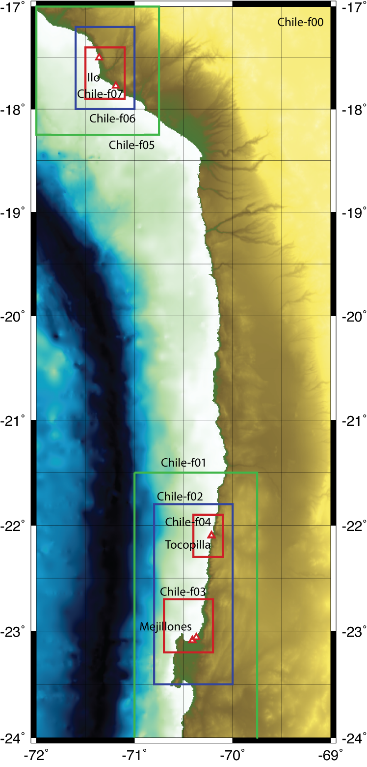

Figure Example of a collection of nested grids.

Finally, the fifth column shows the name of the displacement grid (which should have the same resolution as the bathymetry grid, and should fit completely within it) or, if the source is well outside of that grid, the string “NO_DISPLACEMENT_FILE_GIVEN”. Again, this grid is in NetCDF format, but here uplift is positive, subsidence is negative.

The grid names are featured in the output file: for instance, the gridfiles for the upper grid timesteps are named “Chile-f00.xxxxxx.grd” where xxxxxx is the number of the timestep. In this case, the gridfile with the maximum waveheights is named “Chile-f00.zmax.grd”.

Currently, the code only does limited checks on the compatibility of the nested grids. It will check to make sure that parent and child are registered correctly relative to each other but if two separate child grids overlap the code will not issue a warning and may seemingly run correctly producing unreliable results. Likewise, if a child is registered to its grandparent instead of its parent, the code will run but the child grid will have stepped down from its grandparent with an

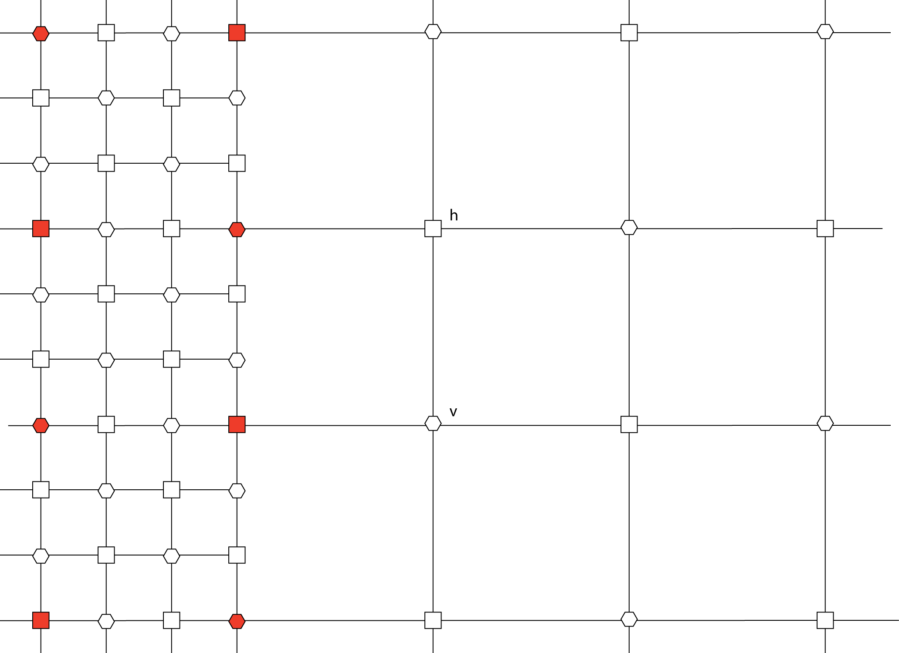

Figure Finite difference scheme at the boundary of a child grid. The squares represent waveheight nodes, the circles are velocity nodes. The child grid is overlain on the left on top of its parent (the coarser background grid). The red symbols represent the gridpoints that are common between the two grids. In order to have overlapping gridpoints (of the correct type), the ratio between parent and child grid spacing needs to be an odd integer (preferably 3 or 5) and the boundaries of the child grid need to coincide with gridlines of the parent. If either of these conditions is not met, the code will exit with an error message.

unreasonably large reduction in grid size. If complex problems are run with multiple nested child level it becomes very important to keep track of their relations.

The locations of the timeseries are defined in a simple table (e.g. Chile-sta.xy):

|  |  |
| --- | --- |
| **Chile-sta,xy** | |
| *1* | 3 |
| *2* | -23.04 -70.50 |
|  | -23.04 -70.49 |
|  | -23.04 -70.48 |

*1* – number of locations

*2* – latitude and longitude pair for every location.

Note that if this file does not exist or is incorrectly formatted, the code will not stop, but simply assume there are no locations read in.

The tsunami code is run as follows:

|  |
| --- |
| *cnltsunami_pas par=Chile.par* |

For testing purposes, it’s preferable to let the output be written to the screen (default) so that one can keep track of the progress, or lack thereof. Every 100 steps the code will output a line so it’s easy to compute the expected runtime by taking the number of expected timesteps (tend/dt), divide it by hundred an multiply by the actual time between 100 timesteps. For fine grids (and thus small timesteps) and very long paths (e.g. Alaska to Indonesia) which require 20 hours or more of simulation time, the process can easily take several days to a week. For local events (e.g. 4 hours of simulation and fin, but small local grids) the code can finish in as little of 15 minutes to a few hours.

Appendix B Generic Mapping Tools (GMT)

For data handling as well as presentation purposes we make extensive use of the free GMT (Generic Mapping Tools) package developed and maintained by the University of Hawaii (<http://gmt.soest.hawaii.edu/>). This package can be downloaded freely from the aforementioned website, which also includes extensive documentation and manuals. In this appendix we will discuss the data formats and also present a few example scripts used for plotting the results.

GMT Gridded data

The default data format for gridded data in GMT is NetCDF (<http://www.unidata.ucar.edu/software/netcdf/>). Although this is a flexible format, the URS tsunami code (cnltsunami) reads only a specific subset of the NetCDF format, which need to be specified when writing the file in GMT by appending the characters “=10” to the grid-file name:

xyz2grd topo.xyz -Gtopo.grd=10 –I10c –R100/110/-10/-5

converts an ascii file named “topo.xyz” with “lat lon height” columns to a gridfile named “topo.grd” using the format(=”10”) compatible with the URS code. Note that GMT will automatically recognize the subformat that it reads in, so there is no need to specify the type when reading in a file in GMT.

GMT uses two alternative grid representations: gridline and pixel (cell). The difference between the two are the actual location of the cell in relation to the grid boundaries. In gridline representation, the boundaries of the grid (as specified in the NetCDF header and the command line arguments (-R, see above) also correspond to the boundaries of the outer cells. Therefore, the number of cells in the x-direction corresponds to (lonmax-lonmin)/dlon +1. In the case of the pixel representation, the boundaries of the grid correspond to the centers of the outer cells, so that the total number of cells in the x-direction is (lonmax-lonmin)/dlon. Although the tsunami code handles both alternatives, it is preferable to use the pixel representation.

GMT Plotting scripts

Final results (waveheights, disaggregation) can be plotted using GMT, we have included several Unix scripts that produce plots. The first one is meant to plot the waveheight for different return periods:

|  |  |
| --- | --- |
| **plotamp** | |
| *1* | set R = -R113.5/114.5/21.8/22.9 |
| *2* | set E = -E340/45 |
| *3* | pscoast $R -G150 -N1,100 -N2 -W1 -JM5 $E -Df -K -Y2 -P>amp.ps |
| *4* | awk '$3 < 40 && $3 > 15 {print $1, $2, $7, $7}' o_amp |psxyz ${R}/0/15 -B.5f.1g.1/.5f.1g.1/5f1WSneZ:"Exceedance height (m)"::." 2475 yr return period at 30 m contour": -JM -JZ1 -So.05 -Camp.cpt -H $E -O -K>>amp.ps |
| *5* | psscale -Camp.cpt -D.25/4.5/2.0/.1 -O >> amp.ps |

*1* – csh command: sets variable R to contain the map boundaries in GMT

*2* – csh command: set variable E to contain the view angle of the 3D plot in GMT

*3* – gmt command: plot map of the coastline

*4* – awk command: select points with bathymetry between 40-15 m from file named o_amp | GMT command to plot the waveheights on map

*5* – gmt command: plots color scale on page

|  |  |
| --- | --- |
| **plothazardcurve** | |
| *1* | psxy S-0001 -R.1/15/1e-4/1 -W5/205/0/0 -JX5l/5l -B1f3g2WSn -P -K > hazcurve.ps |
| *2* | awk '{print $1, $3}' S-0001 | psxy $2 -R -W5/205/205/0 -JX -O -K >> hazcurve.ps |
| *3* | psbasemap -R0.1/15./1/1e4 -JX5l/-5l -B1E -O >>hazcurve.ps |

*1* – gmt command: plots the probabilistic hazard curve

*2* – gmt command: plot the hazard curve without sigma contribution

*3* – gmt command: plots the axes and labels

|  |  |
| --- | --- |
| **plotmdeag** | |
| *1a* | set arps = (72 475 975 2475 ) |
| *1b* | set arpstr = (0072 0475 0975 2475 ) |
| *2* | set BOX = -R100/130/-5/25 |
| *3* | source sitelist.csh |
|  | set i=0 |
| *4a* | foreach site ($number) |
|  | @ i++ |
| *5a* | set infile = S/S-$site |
| *5b* | set name = S-$names[$i] |
|  | set j = 0 |
| *6* | foreach rtp ($arps) |
|  | @ j++ |
| *7a* | cat << END > mredeag.cpt |
|  | -30 255 0 100 -2 255 0 100 |
|  | -2 205 000 000 -1 205 000 000 |
|  | -1 205 205 000 0 205 205 000 |
|  | 0 000 205 000 1 000 205 000 |
|  | 1 000 205 205 2 000 205 205 |
|  | 2 000 000 205 30 000 000 205 |
|  | B 0 0 0 |
|  | F 255 255 255 |
|  | N 128 128 128 |
| *7b* | END |
| *8* | echo "pscoast ${BOX} -G150 -W1 -N1/5/255 -JM6 -E165/35 -B20f5/10f5/20f10 -Di -P -K -Y2 >deag.ps" > plot_tmp.csh |
| *9* | awk '$3 == rtp {printf("echo %8.3f %8.3f %12.6e | psxyz %s/0/25 -N -JM -JZ3 -So.05b%012.6e -G255/000/100 -W1 -E165/35 -O -K>>deag.ps\n", $1, $2, 0, BOX,$4)}' rtp=$rtp BOX=$BOX $infile >>plot_tmp.csh |
|  | awk '$3 == rtp {printf("echo %8.3f %8.3f %12.6e | psxyz %s/0/25 -N -JM -JZ3 -So.05b%012.6e -G255/000/000 -W1 -E165/35 -O -K>>deag.ps\n", $1, $2, $4,BOX,$4+$5)}' rtp=$rtp BOX=$BOX $infile >>plot_tmp.csh |
|  | awk '$3 == rtp {printf("echo %8.3f %8.3f %12.6e | psxyz %s/0/25 -N -JM -JZ3 -So.05b%012.6e -G102/204/255 -W1 -E165/35 -O -K>>deag.ps\n", $1, $2, $4+$5,BOX,$4+$5+$6)}' rtp=$rtp BOX=$BOX $infile >>plot_tmp.csh |
|  | awk '$3 == rtp {printf("echo %8.3f %8.3f %12.6e | psxyz %s/0/25 -N -JM -JZ3 -So.05b%012.6e -G102/204/203 -W1 -E165/35 -O -K>>deag.ps\n", $1, $2, $4+$5+$6,BOX,$4+$5+$6+$7)}' rtp=$rtp BOX=$BOX $infile >>plot_tmp.csh |
|  | awk '$3 == rtp {printf("echo %8.3f %8.3f %12.6e | psxyz %s/0/25 –N -JM -JZ3 -So.05b%012.6e -G196/137/040 -W1 -E165/35 -O -K>>deag.ps\n", $1, $2, $4+$5+$6+$7,BOX,$4+$5+$6+$7+$8)}' rtp=$rtp BOX=$BOX $infile >>plot_tmp.csh |
|  | awk '$3 == rtp {printf("echo %8.3f %8.3f %12.6e | psxyz %s/0/25 -N -JM -JZ3 -So.05b%012.6e -G255/128/000 -W1 -E165/35 -O -K>>deag.ps\n", $1, $2, $4+$5+$6+$7+$8,BOX,$4+$5+$6+$7+$8+$9)}' rtp=$rtp BOX=$BOX $infile >>plot_tmp.csh |
|  | awk '$3 == rtp {printf("echo %8.3f %8.3f %12.6e | psxyz %s/0/25 -N -JM -JZ3 -So.05b%012.6e -G255/000/000 -W1 -E165/35 -O -K>>deag.ps\n", $1, $2, $4+$5+$6+$7+$8+$9,BOX,$4+$5+$6+$7+$8+$9+$10)}' rtp=$rtp BOX=$BOX $infile >>plot_tmp.csh |
|  | awk '$3 == rtp {printf("echo %8.3f %8.3f %12.6e | psxyz %s/0/25 -N -JM -JZ3 -So.05b%012.6e -G205/000/000 -W1 -E165/35 -O -K>>deag.ps\n", $1, $2, $4+$5+$6+$7+$8+$9+$10,BOX,$4+$5+$6+$7+$8+$9+$10+$11)}' rtp=$rtp BOX=$BOX $infile >>plot_tmp.csh |
| *10* | head -1 $infile |awk '{printf("echo %8.3f %8.3f %8.3f0 |psxyz -JM -O -JZ3 -B20f5/10f5/10f5Z:.%s-%syr: -W1p/0/205/0 -Sa.05 %s/0/25 -G0/255/0 -E165/35 >>deag.ps\n",$1, $2, 0, name, rtp, BOX )}' rtp=$rtp name=$names[$i] BOX=$BOX>> plot_tmp.csh |
| *11* | csh plot_tmp.csh |
| *6b* | end |
| *4b* | end |

*1* – csh command: set variable containing return periods

*2* – csh command: set names for output files (similar to return periods)

*3* – csh command: runs a script that populates the list of sites to plote, and assigns names to the sites

*4* – csh command: start loop over the sites (4a), end at 4b

*5* – csh command: sets name of the input file (5a) and name of the title (5b)

*6* – csh command: start of loop over return periods (6a), end at 6b

*7* – csh command: creates a color table to be used by GMT

*8* – csh command: creates temporary gmt script to plot deag. Creates GMT command to plot map of the land areas

*9* – awk command: creates GMT command to plot deag bar (followed by 7 similar lines to plot bars for different deag values)

*10* - csh command: creates GMT command to plot site location on the map

*11* – csh command to run the temporary GMT script which creates the plot